**MAIN PROJECT ELECTRO**

**TITLE OF THE TASK** : Autonomic Self-Learning Systems

**Authors** : Atle Fjellang Sæther (s160905)

Bendik Høye(s184492)

Kenny Duy Luong (s188199)

Ole Bernard Nygaard (s176452)

**DATE** : 2015.05.26

**NUMBER OF PAGES / EXHIBIT** : 99/CD

**SUPERVISOR** : Evi Zouganeli, P35-PS533, Phone : 22 45 32 07

**CARRIED OUT WITH COOPERATION** : Oslo and Akershus University College of Applied Sciences

**CONTACT PERSON**  : Evi Zouganeli

**SUMMARY**

In today's society, self-learning systems are an increasingly relevant topic. The purpose of the project has been to illuminate the most important methods of self-learning systems, develop a self-learning algorithm and a suitable demonstrator and simulator for this. The system described in this assignment is realized with Q-learning by both the table method and the neural network.

**3 KEYWORDS**: Self-learning Systems, Q-learning, Reinforcement learning

Autonomous self-learning systems

**Bendik Høye, Atle F. Sæther, Kenny D. Luong, Ole B. Nygaar 26.05.2015**

Preface

This report describes the various processes that are part of the work of the main project at Oslo University College and Akershus (HIOA), Department of Engineering, Spring 2015.

The report deals with the development of a self-learning algorithm and a demonstrator in the form of a robot that avoids static and dynamic objects in continually changing environments. The assignment is given by HIOA. The report addresses the theory behind the most well-known and used self-learning algorithms, and discusses the pros, cons and applications for these. It also contains a description of the technical solution for the demonstrator and the method used in this project.

The report has been written within a topic that is considered to be non-technical and antasodes to be used for further research and / or learning in autonomous self-learning systems.

The reader is expected to have basic knowledge in electronics and information technology.

This document is optimized for paper

We wish to thank you very much to our employer, University College of Oslo and Akershus, for the opportunity to complete the project and for financial support. We also want to thank supervisor Evi Zouganeli for good cooperation, as well as important and constructive guidance throughout the project.

**Summary**

In today's society, self-learning systems are an increasingly relevant topic. Systems that are not explicitly programmed to perform a specific task but the ability to adapt themselves can be of great use.

The purpose of the project has been to illuminate the most important methods for self-learning systems, develop a self-learning algorithm and a suitable demonstrator for this. It also provides an insight into applications and state-of-the-art within self-learning systems.

The system described in this assignment is realized with Q-learning by both the table method and the neural network. Q-learning is a learning algorithm based on experience. The algorithm is based on an agent exploring his surroundings, where the environment is represented by a number of states. The agent is experimenting with the environment by performing an action, then observing the consequence of this action. The consequence is given in the form of a positive or negative reward. The goal of the method is to maximize the accumulated reward over time.

During the project, a simulator and a demonstrator were developed. The demonstrator consists of an agent who is in an unknown environment with static and dynamic obstacles. Over time, the agent will learn what actions must be taken to navigate without colliding. The agent perceives the environment by means of five sensors mounted in the front. The simulator is developed in MATLAB with the intention of being the most similar to the physical model. The physical model can either be trained or used by simulated values. The application's user interface displays relevant data for the system during simulation.

Simulation results show that both the neural network and the table model, the simulated agent is capable of navigating in an unknown environment, while the physical model of handling static barriers is basic physical constraints and the project's time range.

Further work for the project may include, inter alia, the implementation of a larger number of actions for the agent. By introducing speed and degrees of direction change, it is assumed that the agent is able to handle multiple states, including dynamic obstacles.

**Table of Contents**

Preface ...................................................................................................................................................................... 5

Summary .......................................................................................................................................................... 7

Table of Contents .......................................................................................................................................... 9

Figure List .............................................................................................................................................................. 11

Table List .......................................................................................................................................................... 12

Introduction ............................................................................................................................................... 13

1.1 Business Issues ................................................................................................................................... 13

2 Theory ............................................................................................................................................................. 15

2.1 Machine Learning...................................................................................................................................... 15

2.1.1 Supervised Learning ................................................................................... 16

2.1.2 Unsupervised Learning .......................................................................... 16

2.1.3 Reinforcement Learning . ..................................................................................... 16

2.2 State-of-the-art .................................................................................................................................... ..16

2.2.1 Autonomic car .................................................................................................................................. 16

2.2.2 spam filter .............................................................................................................................. 17

2.2.3 Virtual organism ........................................................................................................................... 17

2.2.4 Connected grid , self-learning monitoring ................................................................................ 17

2.2.5 Q-Learning ...................................................................................................................................... 18

2.2.6 Q function ................................................................................................................................... 20

2.3 Exploration or exploitation ............................................................................................................ 23

2.3.1 e-greedy ......................................................................................................................................... 24

2.3.2 Boltzmannfordeling .......................................................................................................................24

2.3.3 Finnable Neural Network ........................................................... 25

2.4 cost Function ................................................................................................................................. 30

2.5 Back-propagation algorithm ......................................................................................................... 30

2.6 Fuzzy Logic ....................................................................................................................................... 31

2.6.1 Behaviors .................................................................................................................................... 32

3 Technical solution .................................................................................................................................... 35

3.1 The agent ................................................................................................................................................ 35

3.1.1 structure .................................................................................................................................... 36

3.1.2 Electronics ..................................................................................................................................... 37

3.2 The arena ............................................................................................................................................... 44

3.2.1 Dynamic obstacles .......................................................................................................... 45

4 System Solution .............................................................................................................................................. 47

4.1 Q-Learning with the table method .................................................................................................... 49

4.2 discretization ....................................................................................................................................... 50

4.2.1 state space ......................................................................................................................... 50

4.2.2 reward Function ........................................................................................................................ 53

4.2.3 exploration Function ...................................................................................................................... 54

4.2.4 implementing .............................................................................................................................. 54

4.3 Q-Neutral Network Learning (Linear Function Approximation) .............................................. 57

4.3.1 reward Function ........................................................................................................................ 59

4.3.2 Forwarded Neighboring Network (Feed Feed) .................................................................... 60

4.3.3 Updating Weight Matrices ......................................................................................................... 61

4.3.4 Behaviors ........................................................................................................................................ 65

5 Results...................................................................................................................................................... 67

5.1 Procedures for simulation ..................................................................................................................... 67

5.2 exploration Function ......................................................................................................................... 68

5.2.1 Alpha and gamma ............................................................................................................................... 70

5.3 Newral Network ..................................................................................................................................72

5.3.1 Alfa ................................................................................................................................................. .72

5.3.2 Gamma ........................................................................................................................................... 73

5.3.3 Comparison ............................................................................................................................... 74

5.4 Simulation of Dynamic Systems Obstacles ................................................................................ 77

6 Discussion...................................................................................................................................................... 83

6.1 Comparison of demonstrator and simulation .............................................................................. 83

6.1.1 Sensorer ........................................................................................................................................... 83

6.2 Dynamic obstacles .......................................................................................................................... 84

6.3 method Options .......................................................................................................................................... 85

6.3.1 Filling and coincidence ........................................................................................................... 85

6.3.2 Research function and selection of parameters .................................................................... 85

6.3.3 discretization ................................................................................................................................ 86

6.3.4 Project results ................................................................................................................... .86

6.3.5 Additional work ................................................................................................................................. 87

6.4 Independent Agent ............................................................................................................................... 87

7 Conclusion .................................................................................................................................................... 89

7.1 Other work ...................................................................................................................................... 90

7.1.1 Resources ........................................................................................................................................ 90

8 Bibliography ............................................................................................................................................ 91

9 Attachments ............................................................................................................................................. 95

9.1 A) Connection diagram ..................................................................................................................... 95

9.2 B) Flow chart for loss ellmetoden .................................................................................................... 97

9.3 C) Floating scheme for neural network ............................................................................... 98

9.4 D) Physical form flow chart ..................................................................................................... 99

(Figure List)

Figure 2-1 -Illustration of the principle of state, action and reward ......................... 19

Figur 2-2 -Illustration of agent sequence ....................................................... 19

Figure 2-3 - Illustration of the agent's experience ....................................................... 19

Figure 2-4 -Example of condition room ................................................................ 21

Figure 2-5 -Table table with associated Q-values ​​.......................................... 22

Figure 2-6 -Illustration of a natural neuron ............................................................. 26

Figure 2-7 -Illustration of an artificial neuron with input, weights and output a .............. 26

Figure 2-8 -Plot of the activation function tanh (x) ............................................ 27

Figure 2-9 -Illustration of an artificial neural network ......................................... 28

Figure 2-10 -Illustration of gradient descent principle .............................. 31

Figure 2-11 -Memberhood function .................................................................. 32

Figure 2-12 -Fuzzy Logic ................................................................................... 32

Picture 3-1 -WLtoys model A969 with bodywork ................................................ 35

Figur 3-2 -WLtoys model A969 without bodywork ........................................................ 35

Figure 3-3 -Agent 1 with sensor rig and top plate ............................................................. 35

Figure 3-4 - Measured turn radius for agent version 1 .................................................. 36

Figuration 3-5 -Built of bracket for the motors ................................................ 36

Figure 3-6 -Motor bracket with both motors mounted ............................................. 36

Picture 3-7 -Motor bracket attached to the disc ............................................................ 37

Figure 3- 8-Ready Agent Version 2 ....................................................................... 37

Picture 3-9 -Overview of the agent's electronics ................................................. 37

Picture 3-10 -Test Environment for measurement of sensor detection angle and deviation..............................................................................39

Figure 3-11 -Testing of a sensor connected to an Arduino UNO .................................................. 39

Picture 3-12 -Simple detection angle for HC-SR04 .......................................................... 39

Picture 3-13 -Concept drawing for HC-SR04 ......................................................... 40

Figure 3-14-Timer for trigger / echo for HC-SR04 .......................................... 40

Figure 3-15 -Clip Screen for Arduino UNO R3 .......................................... 41

Figur 3-16 -Step-up converter (adjusting screw at the top) ........................................ 42

Figure 3-17 - Connection diagram of the agent's controller stage .............................. 42

Figur 3-18 -Fast 5V Voltage Regulator ......................................................... 42

Figure 3-19-Engine Driver Connection Schedule. .................................................. ..43

Picture 3-20 -Motor Driver L298N Dual H-Bridge .................................................................. 43

Picture 3-21 -Picture of the arena ............................................................................ .44

Figure 3-22-System for Dynamic Obstacles ................................................... 45

Figure 3-23 -Photo of motor kling against gummihjul ............................................ 46

Figur 3-24 -Overview over electronics for the rotating barrier system ........... 46

Figure 4-1 -Illustration of the agent with the field of view of the five sensors ........... 47

Figur 4-2 -Aggent rotation and rotation change .. .......................................... 48

Figure 4-3 -Illustration of the principle Q-learning with the table method .......... 49

Figure 4-4 -Illustration of the agent's field of view ..................................................... 50

Figure 4-5 - Division of sectors ... .................................................................. 51

Figure 4-6 -Screen Dump of User Interface tt for simulation ............................... 56

Figure 4-7 -Screenshot from simulation of dynamic obstacles ..................... 56

Figure 4-8-Communication between Arduino and MATLAB .................................................. 57

Figure 4-9 -Agent's Neural Network ................................................................. 58

Figure 4-10 - Conceptual sketch for the agent's learning process with NN .................59

Picture 4-11 -Gradient descent for square function ................................. 64

Figuration 5-1 -Composition of step of the exploration function with Q-table ...........69

Figuration 5-2-Comparison of reward for exploration functions with Q-table l ..............69

Figure 5-3 - Simulation of Alpha Values for the table method ...................................... 70

Figure 5-4 - Simulation of gamma values ​​for the table method .............................. 71

Figure 5-5 - Alpha Network Values ​​for Neural Networking (Test 1) ........................................... 72

Figure 5-6 - Simulation of Alpha Values ​​for Neural Network (Test 2) ..........................72

Figure 5-7 -Total Reward Q for Different Values ​​of Gamma for Neural Network ................. 73

Figure 5-8 - Simulation for comparison of the table method and the neural network ........75

Figure 5-9 -imulation of overall reward for the table method ............................................ 75

Figure 5-10 - Simulation of overall reward for neural network .................................. 76

Figure 5-11 - Simulation of Cost Function for Neural Network ....................................... 76 Figure 5-12 - Simulation of the number of steps in the table table ............................ 77

Figue 5-13 - Simulation of reward for the table method .................................. 78

Figure 5-14 - Simulation of the number of steps for the neural network ............... 78

Figure 5-15 - Simulation of reward for neural network .................................... 79

Figure 5-16 - Simulation of Cost Function for Neural Network ........................................... 79

Figure 5-17 -imulation of step for system with dynamic barriers for neural network (4000 attempts) ......... 80

Figure 5-18-Simulation of reward for system with dynamic barriers for NN (4000 attempts) ................... 80

Figure 5-19 -imulation of cost function for system with dynamic barriers for NN (4000 attempts) .. ..... 81

Figure 9-1 - Other electronic circuit diagram (Part 1) ..................................................95

Figure 9-2 - Connection diagram for voltage regulator and sensors (Part 2) ......................... 96

Figure 9-3 - Flow chart for the table method .............................................. 97

Figure 9-4 -flow chart for neural network ............................................................ 98

Picture 9-5 -Flash Form for Physical Agent .............................................................. 99

(Table List)

Table 1 sequence of experience ....................................................................... 22

Table 2 - Comparison of theoretical data for IR sensors and ultrasonic sensors ..........38

Table 3-Measured deviation and detection angle for HC-SR04 ................................. 40

Table 4 -Pin Configuration for Arduino UNO R3 .......................................... 41

Table 5 -Logical Engine Engine Driver L298N Dual H-Bridge for Engine1 ........................ 43

Table 6 -Logical Engine Engine Driver L298N Dual H-Bridge for Engine 2 .......................... 43

Table 7 - Interface of state table for static barriers ................................. 52

Table 8 -Overview of charts in results ............................................................ 67

Table 9 -Results from simulation of alpha values ​​for the table method ................... 70

Table 10 -Results from simulation of gamma values ​​for the table method ........................ 71

Table 11 -Results from simulation of alpha values ​​for neural networks................. 73

Table 12 -Results from simulation of gamma values ​​for neural networks ............................ 74

Table 13 -Results from simulation of comparison of table method and neural network ..................... 74

Table 14 -Overview of total values ​​for dynamic simulation ...................................................... 77

**Introduction**

Self-learning systems have always been an important part of artificial intelligence. A self-learning system is characterized by the non-programmable style of performing an explicit task, but based on empirical experience, recognizing patterns, adapting to different environments, and optimizing the efficiency and accuracy of a system.

Within machine learning there are many different self-learning methods, and this report presents the most well-known methods within this field.

Autonomous self-learning systems are becoming increasingly relevant because the system is capable of adapting segregated or completely unknown situations. It learns from experience and needs less information at start-up as it acquires information along the way. Within autonomous self-learning systems and self-propelled robots, preventing obstacles is a key task. This report addresses a demonstrator for such a system, realized with Q Learning Room presented later in the report, giving a description of the algorithm and results.

The report's results are based on simulations, showing test results for parameters, as well as a comparison of Q learning, implemented average network and table method. The report's discussion discusses the choice of methods and parameters, the importance of work and further work with, among other things, Åkonstruer's independent agent, making it able to handle dynamic barriers.

**1.1 Business Issues**

The task has consisted of conducting a study of methods for autonomous self-learning systems and making a demonstrator undergo such a system.

The client's wish is that a literature study of the most important methods for self-learning systems today, as well as application examples for these, will be done. A single method will also be developed to realize a self-learning system to be demonstrated in a suitable demonstrator, and a report will be prepared to present the work, evaluate the results, propose improvements and discuss further work.

The literature study is limited to the subject of machine learning, and will not address other self-learning methods.

The work must be able to be quality assured by demonstrating, as well as documented by statistics and figures.

**2 Theory**

Before looking at the building of a self-learning system, one can look forward to what the term learning is. Learning is often defined as a change in behavior as a result of experience (St. Olavs Hospital, externally). The property organisms have as defined as learning is one of the pillars of what is called intelligence which, among other things, is defined as an ability to acquire and apply knowledge and skills. Humans and animals are considered intelligent, among others, based on their ability to learn from experience.

**2.1 Machine Learning**

This sub-chapter is based on the theory of S. Marsland, 2009. Machine learning is a form of artificial intelligence that focuses on the development of avalion algorithms. Self-learning systems in most cases take part of natural intelligence, including memory, adaptation and generalization. Unlike traditional non-learning systems, the method makes it possible to construct a system that is capable of expanding, adapting to new information and learning a given task without being specifically programmed for this. For machine learning, this system is called an agent. By using memory, an agent can recognize the previous time it was in a similar situation and what action it did. Based on the outcome from the previous time, if it was correct, choose to repeat the action, or try something new. By generalizing, the agent can recognize similarities in illicit situations, thus using experience from one situation and applying this experience in another.

The goal of the method is to get an agent to modify or customize his actions to make them as accurate as possible, the accuracy measured in how well chosen action reflects correct action.

In order to realize this concept, machine learning uses principles from statistics, mathematics, physics, neurology and biology.

When mankind about machine learning and self-learning systems, it's mainly algorithms that are the main product. The actual process in these algorithms can be compared to data mining. Data mining is a process that analyzes data from different perspectives and summarizes it for useful information. Using methodologies to find patterns, but instead of extracting data for human interpretation, the information is used to improve the understanding of the agent. In order for the agent to be able to learn, it must know how it will improve and whether it will improve or not. There are 16 more ways to solve this, which in turn provides several main categories in machine learning: Veilede learning, unattended learning and reinforcement learning.

**2.1.1 Supported Learning**

An agent is given a training set with, for example, images of a face and images without face. The agent is then prepared through a training process where it gives a forecast of what the image is like. Whenever the forecast is not correct, the agent will be corrected. This process continues until the model achieves a desired level of accuracy. Since the algorithm does not have a definite definition of what is a face and not, it must thus learn this by means of examples. A good algorithm will eventually be able to estimate whether an image is of a face or not. The learning methods are best explained by examples

**2.1.2 Unsupervised Learning (Unsupervised Learning)**

In case of unattended learning, no information is marked. That is, the system is not being told what is the image of a face and what is not. As a result, there is no correction or reward to indicate a potential solution, but the algorithm attempts to identify the similarities between the images, then categorize them and divide them into groups.

**2.1.3 Reinforcement Learning**

For reinforcement learning, the algorithm is told when the response it issues is incorrect, but the sheep suggests how to correct it. It has to explore and try out different solutions for it to find out how to respond. This is a sort of interception of guided learning and unattended learning. Examples may be learning to play a board game or a robot that will learn to go. Each time an agent performs an action, it receives a reward or penalty based on the desired outcome of the action. For example, when an agent is trained to play a board game, it gets a positive reward for victory, and a negative reward for loss. All other cases give no reward.

**2.2 State-of-the-art**

To get a better understanding of what machine learning is and what it is capable of, a literature search was made to map state-of-the-art intelligence. It may be useful to use applications that have adopted the concept to give an idea of how extensive machine learning is and what it is capable of accomplishing today

**2.2.1Autonomic car**

STANLEY is a Volkswagen Touareg equipped with camera, radar and distance measurement using laser to perceive the environment, and software to control direction, braking and acceleration. The car was designed for high speed desert driving without human impact, where the robot software 17 was basically based on machine learning. STANLEY won the "The Grand Challenge" by the Defense Advanced Research Projects Agency (DARPA) in 2005 to launch innovative research on unmanned vehicle navigation (Thrun et al, 2006) (Russel & Norvig, 2010)

**2.2.2 Spam filter**

Using a junk mail filter, billions of emails are classified as junk mail every day. This allows the recipient to save time by not deleting many unwanted emails. As different tactics to get through spam filters are becoming increasingly sophisticated, this would not be possible without self-learning algorithms that can recognize patterns of junk mail content and recipient preferences, and adapt to the information continuously. (Russel & Norvig, 2010)

**2.2.3 Virtual organism**

OpenWorm Project (OWP) is a project dedicated to creating the world's first virtual organism in a computer. The organizationalism it is working with is a nematode called Caenorhabditis elegans (C. elegans) .C. Elegance has a very simple brain that operates with 302 neurons, compared with the human brain that has between 80-100 billion. Thanks to this simplicity, many of them have a good understanding of how these neurons are connected and communicate with each other. This knowledge has made it possible to create a computer program that simulates the brain of the worm .OWP has taken this knowledge a step further and uploaded the program to a LEGO robot. The robot has a number of sensors that represent the sensational impression of the snake that provides information about its surroundings. This implementation showed that the program was able to redirect the robot in the same way that the worm would do to avoid the same obstacle completely without preprogramming. This is currently a new research, but in research, the robot will be able to perform more tasks and better copy hurricane's ability to move and find food. The goal is to build a robot that is a complete copy of the worm, all the way down to synthetic muscles in the actual locations of the worm's body. (Shadbolt, 2015)

**2.2.4Connected grid, self-learning monitoring**

Connected Grid is a solution that is being developed by the Norwegian company eSmart. The solution monitors the power supply and provides information about the power consumption to the consumers. The system makes it possible to measure and analyze everything in a new way, which means that the power provider can better utilize its resources. Connected grid gives a full overview of how much power is used when, too intelligent to be able to offer just as much as is necessary into the home. This is facilitated by "machine learning", which is based on the fact that the more information the system's devices get, the smarter it becomes. The motivation behind this is the fact that power produced can not be stored on a large scale, used only on a continuous basis. By utilizing the consumption information, power providers can move the energy where it is needed, for example, in the morning when most showers, and in the same way save resources when the hot water tank is not in use. The main goal is that electricity suppliers will to a greater extent avoid invest too much or too little at the wrong time, which can be very expensive both for the consumer and the supplier. Part of the Connected Grid is Connected Drone, which is specially designed to inspect the power grid using high resolution cameras, navigation and thermal sensors which detects heat. The drones are used to find faults in electrical equipment, and report about rotten trees that are at risk of falling over power piles. The drones are clever enough to distinguish between rotten and healthy trees. The dronning is also self-learning, and reap information every time it is on mission. The more data it collects, the smarter becomes the drone. (Bie, 2015)

**2.2.5Q-Learning**

Q-learning is referred to as one of the best-known and most widely used algorithms in the field of reinforcement learning, and is based on learning from experience. The method was first introduced by C. J. Watkins in 1989 and is a primitive form of learning, but is nevertheless a good basis for more sophisticated systems (Chen, 2006).

The algorithm is based on an agent exploring his surroundings, where the environment is represented by a number of states. The agent is experimenting with the environment to perform actions that it is able to perform, then to observe the consequence of this action. Consequence is in this case in the form of a reward. The reward is a weighted sum of the expected value of all future rewards. The purpose of this activity is to maximize the accumulated reward over time by selecting that action in a specific state that gives the highest reward. The action that gives the highest long-term reward is to be regarded as the optimal action. Once the agent has performed all actions in all states enough times, it will learn an optimal action pattern, which is the overall goal (Marsland, 2009)

Figure 2-1 is taken from the book "Machine Learning" by Tom Mitchell, p. 368. Copyright 1997, McGraw-Hill Science / Engineering / Math. Translated to Norwegian

The activity mentioned above can be represented as a sequence of state-action-reward:

This means that the agent was in state s0, performed action a0 which resulted in the received reward r1 and ended up in state1. Furthermore, it performed action a1, received reward r2, and ended up in state s2, and so on.

This sequence is made up of experiences where experience is given as there Experience states that the agent was in state s, performed action a, received reward r, and ended up in state s ', and represented by <s, a, s', r>. (Poole, D. & Macworth, A. 2010)

**2.2.6 Q function**

In order for the agent to be able to draw lessons from the mentioned sequences and thus call it an experience, it has a table called Q-table, which serves as its memory. All data points stored in this table are called Q-values (Q-values) and represent where it is desirable to perform a specific action in a specific state (Teknomo, 2005)

One experience adds a data point Q (s, a) in the table space represents the agent's current estimate of the optimal Q value. It is this information the agent uses to learn an optimal action pattern. The size of the table depends on how many states and actions are included in the problem you are trying to solve, the number of states giving the number of rows, while the number of actions gives the number of columns. For example, if you have 20 states and 3 actions you will get a table of 20x3  
(Poole, D. & Macworth, A. 2010).

Before the agent begins to experiment, it knows nothing else what actions it is capable of performing, and the Q-table is therefore empty. That is, all Q values are equal to 0.

The key to the method described above is to update the Q value assigned to the agent when performing an action in a given state of the current data point when it gets an experience.

This value is given by the Q function

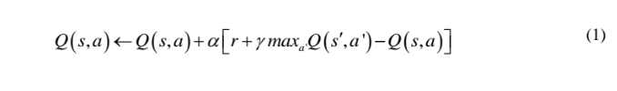

or more transparent:

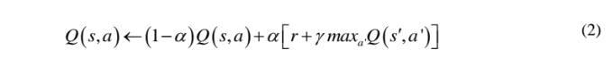

there

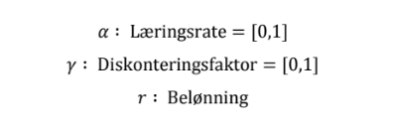

The learning rate dictates how much of previously acquired lessons to be replaced with new information. At *α* = 1, previous values are replaced with new information, while *α* = 0 is no update. In other words, the agent at *α* = 1 assumes that the last reward and resulting state are representative of future values.

-------------------------------------------------------------------------------------------------------20p---

The discount factor indicates the weight of all future rewards. If *γ* = 0, the agent will only assess current rewards while thinking more long-term and strive for higher future rewards as *γ* approaches 1.

The reward is defined when making the program in the form of reward features, and may be positive or negative. What this reward value is defined is not critical. However, it is important that there is a clear distinction between the reward for good actions and the reward for bad actions (Teknomo, 2005).

When the algorithm is added to a new experience, a new Q value is estimated, and the old table value of the Q table is updated with the new one.

One can illustrate by example how the condition table is updated:

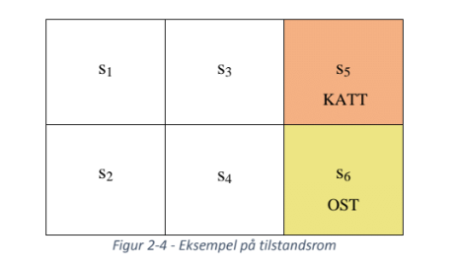

Suppose the agent is a mouse that is placed in a room divided into six states, see Figure 2-4. In state s6 there is an ostebit, while in state s5 there is a cat. If the agent finds the ostite, it receives a reward of 10 while it receives a reward of -10 if it moves to the state where the cat is located. These two states are called terminal states. The agent explores the environment until one of the terminal states is reached before a new iteration (attempt) is started.

The agent can perform four actions: up, down, right, left. If it moves in a direction where there is a wall, it gets a reward of -1, and it stays in the same state. All other states have a value equal to 0 (Poole, D. & Macworth, A. 2010). This is implemented in the algorithm using reward features:

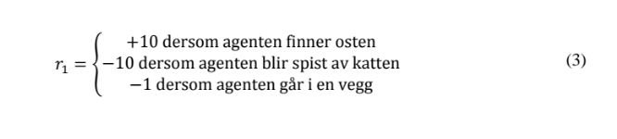

-------------------------------------------------------------------------------------------21p----

The agent has no information about his surroundings except that there are six states and four actions, the state at which it is located and any rewards it receives as actions are taken. It also does not know what a reward or punishment is. The Q table is illustrated in Table 1.

By assuming the following sequences of experiences, ⟨s, α, γ, s'⟩ can one illustrate how a sequence updates the Q table:



For the sake of illustration, the learning rate a and the discount factor r are equal to 1 and all Q values have a starting value equal to 0.

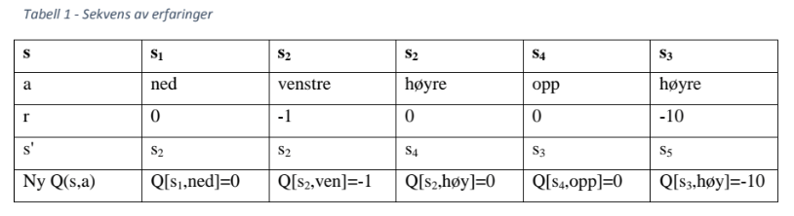

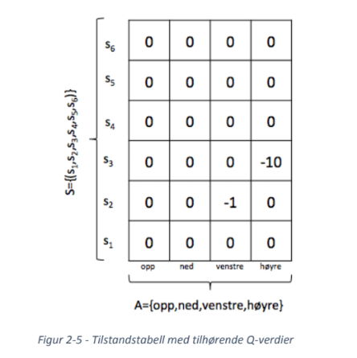After this sequence of experiences, the Q-table with updated values will look like this:

-------------------------------------------------------------------------------------------------22p------

Each experience will update the state table value for the performed combination of state and action, and the Q values will over time converge to optimal values. The more attempts the agent performs, the better the estimates in the Q table will be. In theory, the agent will eventually achieve an optimized Q table and will be able to choose the shortest way to the cheese each time, regardless of the start state.

**2.3 Exploration or exploitation**

One of the challenges of the Q-learning algorithm is that it does not directly tell what the agent should do, but rather serves as a tool that shows the agent what the optimal action is in a given state. This is a challenge because the agent must explore the environment enough times to build a solid foundation that provides a good estimate of the Q values. To solve this, it is implemented an exploration function that determines the strategy the agent will use to select actions, either exploit or exploit (Poole, D. & Macworth, A. 2010).

- Exploration: The agent is bold and does not necessarily choose the best action, with the intention of establishing a better estimate of the Q-values.

- Utilize: The agent utilizes the experience it has already built up and select the optimal action for the state it is in. Thus, the action that gives the highest Q value. It is said that the agent is greedy

The purpose of this feature is to establish a relationship between the two strategies. It is important to explore enough so that the agent builds a solid foundation of the Q values, but it is also important to utilize the already acquired knowledge to ensure the highest possible reward.

There are a number of ways to realize this, but two of the most popular methods are the "Greedy" feature and the Boltzmann distribution, popularly called "softmax":

**--------------------------------------------------------------------------------------------**23p**--**

**2.3.1 ε-greedy**

ε -greedy is a strategy based on always choosing the optimal action except ε of the times and selecting a random action ε of the times.

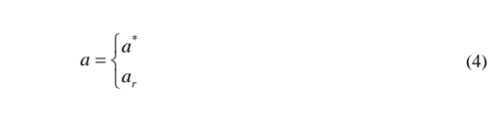

there

α* is optimal action with probability 1- ε  
αγ is random action with probability ε

where 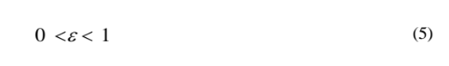

It is possible to change 3 over time. This allows the agent to choose a more random strategy at the beginning of the learning process, then to become more greedy as it acquires more knowledge.

One of the challenges of 3-greedy is that it considers all actions apart from the optimal as equal. If, in addition to an optimal action, there are two good actions and further actions that look less promising, the agent will be advisable to choose one of the two better instead of spending time exploring the bad actions. By using 3-greedy, there is as much likelihood of exploring a bad act as exploring one of the two better. One way to solve this is to use Boltzmann distribution (Poole, D. & Macworth, A. 2010).

**2.3.2 Boltzmann distribution**

This strategy is known as "softmax" action choice and is based on selecting an action with a probability that depends on the Q value. The probability of choosing action a in state s is proportional to 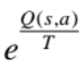, ie the agent in state s selects action a with probability

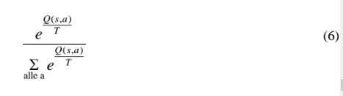

------------------------------------------------------------------------------------------24p-----

Parameter T specifies where random values are to be selected. When T has a high value, actions are chosen to be approximately equal. As T decreases, it is more likely that the actions with the highest Q value will be selected, while the best action will always be selected when T → 0 (Restelli, 2015).

One of the advantages of the Q-learning algorithm is that it is exploration insensitive. That is, the Q values will converge to optimal values regardless of the agent's behavior as long as information is collected. This is one of the reasons why Q learning is one of the most used and most effective methods of reinforcement learning. However, it is a prerequisite that all combinations of state / action are tried out many times, which in most cases means that the exploration and exploitation aspect must be addressed since it is not always possible for an agent to experiment indefinitely (P. Kaelbling & Littman, 1996).

**2.3.3 Artificial Neural Network**

Neural networks (NN) are a concept developed with inspiration from the biology, more specifically how the brain in humans and animals works. As learning takes place in the brain, the idea is that one can get far by trying to copy it. In order to understand the whole of neural networks, one can conveniently look at a simplified explanation of how the brain actually works.

The human brain consists of approximately 100 billion nerve cells called neurons. Each neuron is coupled with thousands of other neurons and communicates via electrochemical signals. Signals that enter a neuron are received via links called synapses, which are located at the end of branches called dendritter. See Figure 2-6. A neuron receives continuous signals through these input-terminals. Nevronet then takes all the signals it receives and sums them up. If this sum is greater than a given threshold, the neuron sends a signal through an output-terminal called axon, which is connected to one or more other neurons dendritter. Neural networks are a simplified version of this concept with a network of artificial neurons (Russel & Norvig, 2010). An artificial neuron is illustrated by Figures 2-7. All the theory described from this point is based on Nielsen, 2015 and Ng et al., 2015.

------------------------------------------------------------------------------------------------25p-------

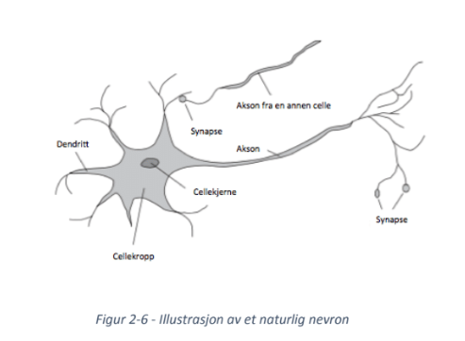

Figure 2-6 is derived from the book "Artificial Intelligence A Modern Approach" by Russel & Norvig, 2010, p. 11. Copyright 2010 Pearson Education, Inc. Translated to Norwegian

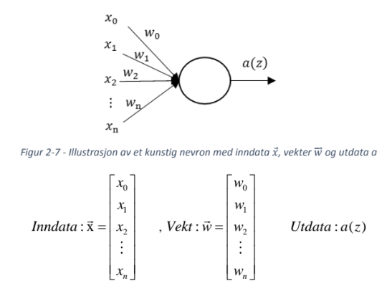

An artificial neuron (node) is a computation unit with one or more inputs-values χ₁, χ₂, χ₃,•••,χn represented as a vector 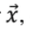, there x0 is bias. Bias has a constant value, often equal to 1. If a bias is not included, it may lead to a limitation of the learning in the neural network. For each input, χ₁, χ₂,•••,χn is an associated weight w₁, w₂,•••,wn, represented by 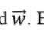. As soon as a value enters the node, it becomes multiplied by its weight. These are the weights that are adjusted by training the network. The node sums all these input values and can be written as z.

----------------------------------------------------------------------------------------------26p--------



z is the product of the weight  and the input .

The output value α(z) = g(•), where g is an activation function given by the hyperbolic tangent function g(z).

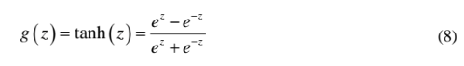

The output is thus defined as a(z).



Hyperbolic forceps function has the following plot, as illustrated by MATLAB in Figure 2-8.

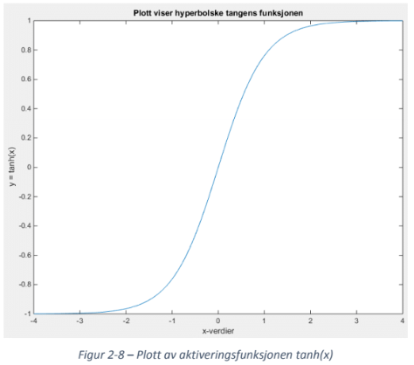

The tanh (z) activation function limits the output to lie in the interval [-1,1].

Activation means the value z calculated in the node using the activation function and sent as output. This value is in itself a little useful. It's only when nodes are connected to an artificial neural network, one can benefit from a neural networking feature.

--------------------------------------------------------------------------------------------27p---------

Figure 2-9 is an example of an artificial neural network. The network consists of several layers, including input layers, hidden layers and broadcast layers. The use of the concealed term has no special significance other than that it is neither an entry day nor an expiry date, and the fact that one does not observe the values represented in these nodes. The number of nodes in the input layer is equal to the number of input values, while the number of nodes in the output layer is equal to the number of output values. When it comes to deciding the number of hidden layers / nodes there is no fasit. Several layers and nodes, on the other hand, will help create a more efficient network, but at the same time require additional computing power. (RSS2014: 07/16 09: 00-10: 00 Invited Talk: Andrew Ng (Stanford University): Deep Learning, 2014)

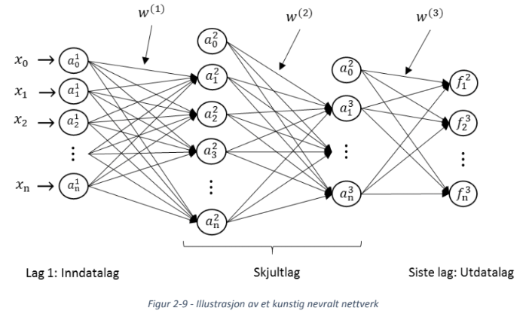

There are several methods for setting up an artificial neural network. One of the most common ones, also used in this project, is called a forward-feed neural network, which means that the information is always fed from the input page and passed on through the network. In other words, output from one layer + bias is used as input in the next. The nodes in the input layer of the network are defined as  and consist of network input values. These values act as input values for the next layer in the network, then given as 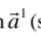(see equation (10)).

----------------------------------------------------------------------------------------28p-----------------

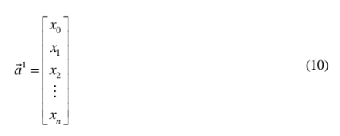

x0 is bias and the number of nodes is represented by n.

Accordingly, the parameter z from equation (8) is given as

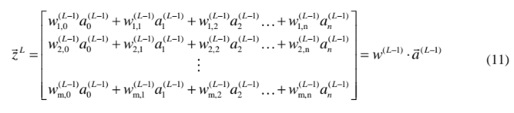

It should be made clear that there is no 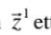since layer 1 is the input values  fed into the network.

The parameter m represents the number of nodes in layer L, while n represents the number of nodes + bias in layer L-1. The weight 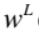is a matrix for the strength of the link between layer L and layer L + 1, as opposed to Figures 2-7 where the weight was a vector. The dimension of the alternation matrix is *mxn*, ie, lines equal to the number of nodes in layer L + 1 and columns equal to number of nodes + bias in layer L, see Figure 2-9.

Accordingly, the output vector 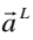is a layer given as

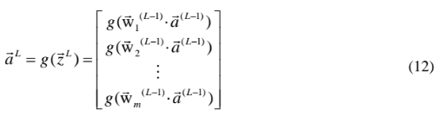

The estimated values in the last layer are a result of the calculations made in the hidden layers, whose output is similar .

----------------------------------------------------------------------------------------29p-----------

**2.4 Cost function**

As mentioned, there are the weights *w* to the links between the layers that are adjusted to train the network. To do this, a cost function is defined by:

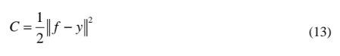

The cost function provides the deviation between the network's estimated (wanted) output value *f* from the output layer and the actual value *y*. As it is desirable that the actual value is as similar to the estimated the value as a result is therefore the goal to . This is done by calculating the partial-derivative 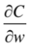 of the weight matrixes using the backpropagation algorithm, to update the weight matrixes.

**2.5 Back-propagation algorithm**

To find the part-derivative one must first determine the deviation between the nodes estimates and the actual value of each node in the network. This is done with the back-propagation algorithm.

The algorithm begins to calculate the deviation in the last layer and works backwards on the network to calculate the deviation of each node in each layer (except for the input layer). The deviation is defined by deviation vector 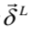, and is equal to the number of nodes + bias in the layer L.

After finding  for each layer, they are used to find the part-derivative of the cost function. The partial derivatives are then used to minimize the cost function by finding a local minimum at gradient descent.

Figure 8 shows the principle of gradient descent on a simple square function, starting from a point of the function and working down to a local minimum. The red arrows in the figure show each step made by the gradient descent algorithm. By taking a lot of steps, you will eventually approach a local minimum. After calculating the partial-derivative for each weight matrix with the back-propagation algorithm, these are used to update the weight matrixes in the Neural Network.

-------------------------------------------------------------------------------------------30p------------

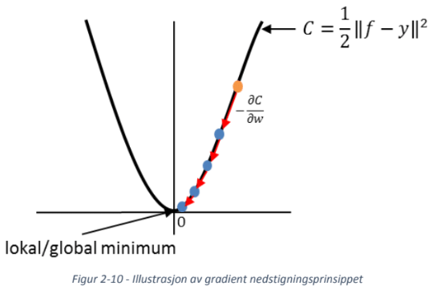

Because the construction of an artificial neural network varies widely based on the problem you are attempting to solve, the procedure is explained in more detail in Chapter 3.

**2.6 Fuzzy Logic**

The theory of fuzzy logic is based on Sunnevåg, K. J. (2007).  
Fuzzy logic is a decision or control model based on diffuse amounts, and inputs classified as degrees of membership in a diffuse amount. A diffuse amount has no sharp limits, and is a set of values belonging to the same definition, where the definition is a diffuse term often described by an adjective. For example: big potatoes or tall people. A diffuse amount is also called semantically variable or seen.

Fuzzy logic classifies input according to how large membership the input has to a set. The degree of membership is graded between 0 and 1, and determined by a membership function.  
The membership function is determined on the basis of knowledge of the subject field, and may be non-linear.  
Input can have membership in several different sets, but can only have full membership in one set.

Figure 2-11 shows an example of a membership function with emphasis on a potato as input.  
Depending on the weight, the potato is graded to the different diffuse quantities: small, medium and large.

-------------------------------------------------------------------------------------------31p---------

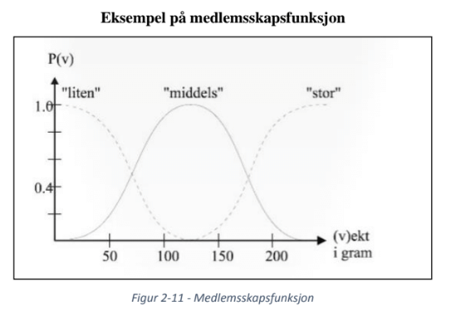

Figures 2-11 are derived from "Decisions on weak information basis" by Sunnevåg, K.J., 2007, Concept Report No. 17, p.245. Copyright 2007. The figure is reproduced without permission.

The fuzzy logic method consists essentially of five links as illustrated in Figure 2-12.

**2.6.1 Mode of action**

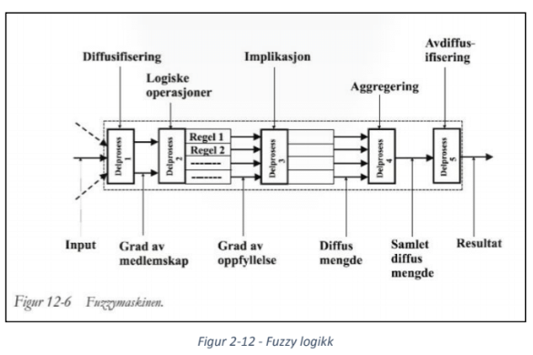

Figures 2-12 are derived from "Decisions on weak information basis," by Sunnevåg, K.J., 2007, Concept Report No. 17, p.250. Copyright 2007. The figure is reproduced without permission.

------------------------------------------------------------------------------------------32p------------

**Fuzzy logic mode of action**

1. Diffusification: Input is graded according to the diffused quantities and the diffused quantities are sent to sub-process 2.

2. Logical rules: the diffused quantities are tested against rules. The degree of fulfillment from each rule is sent to subprocess 3. The rules can be implemented with {and, if, or}, or other methods such as an impact matrix. The rules describe the relationship between the diffused inputs and output.

3. Implication: The received data from subprocess 2 is tested against rules that influence the overall impact of each of the received data. The grades will then be sent to subprocess 4.

4. Aggregation: all consistency quantities are aggregated to an aggregated amount, which is the union of the amounts from subprocess 3.

5. Diffusion: The most representative element is extracted from the aggregated amount. This is usually the center of gravity. That value will then be the control signal.

The fuzzy logic method has a number of advantages in that it is able to handle unpredictable data and model nonlinear relationships between input and output. The principle allows for accurate and real-life classification of data, as data is rarely true or false.

-------------------------------------------------------------------------------------------33p-----------

-------------------------------------------------------------------------------------------34p-----------

**3 Technical solution**

**3.1 Agents**

Two versions of the agent were developed. The first version, which was later replaced, was built on the basis of drivers and mechanics derived from "WLtoys" model "A969" (Figure 3-1 and Figure 3-2). The 1:18 radio-controlled car was delivered with radio and battery. The car measured 285x140x105mm (LxBxH) and could run about 10 minutes on fully charged battery.

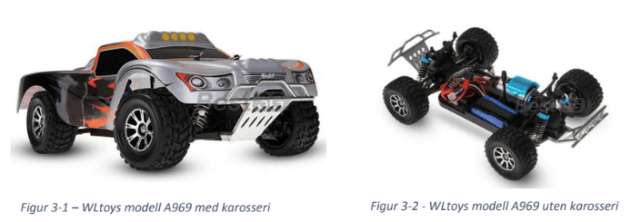

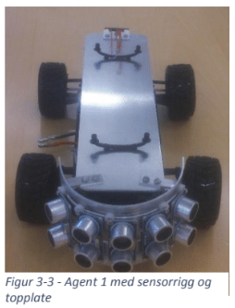As the car was equipped with an Xbee-module and communicated via Bluetooth, the car's original receiver was removed. The driver's servo was adapted to the car's receiver and was therefore replaced in favor of a PWM-controllable servo. To improve agent runtime, the original 7.4V / 1100mAh battery was replaced by a 7.4V / 5200mAh "Fire Bull" battery, which theoretically would give about five times as long driving time.

To fit all the electronics, a 1.5mm aluminum plate was cut and mounted on top of the car (Figure 3-3). The motor driver, microcontroller card and Xbee- module were placed with the engine and the servo on the chassis, while the battery, sensors and voltage regulator were mounted on the new disc for easier access.

Following the above changes, the agent improved battery power, adjustable speed and correct physical size, but it turned out to not have good swing radius. It had particular problems in situations where it had to react in one direction, then switching direction.

-------------------------------------------------------------------------------------------------35p--------

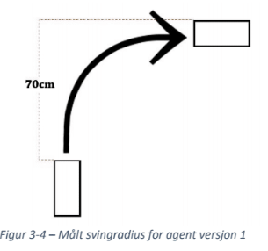The car's turning radius was tested before the conversion was started, and it was measured that the car needed 70 cm to turn 90 degrees to the left or right (Figure 3-4). It thus needed a 140 cm diameter area to turn 180 degrees. It was therefore assumed that a round arena with a diameter of about four meters was required. The arena was built, and it was found that four meters were enough to drive around without obstacles, but that there was too little when the car had to avoid objects.

In parallel with the programming of the first agent, construction of a new agent was commenced. The new agent was based on a model described in Huang, Cao and Guo (2005), where the agent was equipped with two pulleys and a support wheel, and the direction of driving by driving the two pulleys at different speeds or opposite directions.

**3.1.1 structure**

The agent that was eventually used in the demonstrator is designed based on a 21 inch diameter plastic plate. The braking bracket for the motors was cut out of 1.5mm aluminum and bent to the correct shape (Figure 3-5). Then the two motors were mounted (Figure 3-6) before the finished bracket was finally mounted a little bit behind the plate's point of turning (Figure 3-7). Then, the support wheel, the Arduino UNO, the electronic speed controller, battery, Xbee and the five sensors with associated voltage regulator stages previously used on the first, moved to the other agent (Figure 3-8).

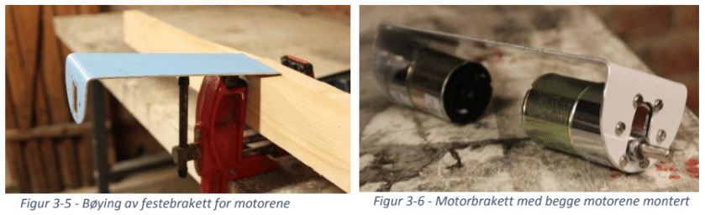

----------------------------------------------------------------------------------------------------------------36p----------------

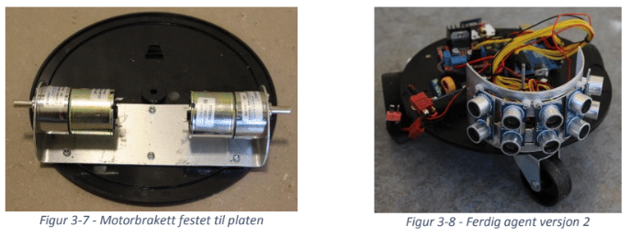

**3.1.2 Electronics**

The two agents were equipped with the same electronics, except that the first version used a servo to control while the other changed direction using two engines. Figures 3-9 show an overview of the agent's electronics. Complete system diagram is shown in Appendix A.

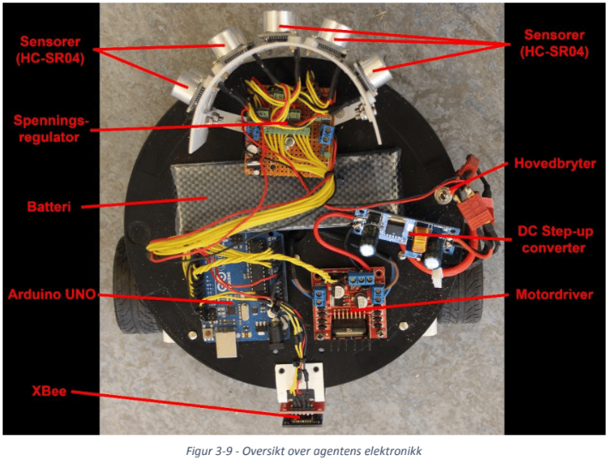

**3.1.2.1 Sensors**

Part of the construction was to equip the agent with distance sensors that could provide the agent with information about the surroundings. Distance sensors come in different types for different purposes and it was therefore important to determine which type would best suit this project. It was mainly between IR sensors and ultrasonic sensors due to the range, price and availability of the sensors

-------------------------------------------------------------------------------------------------37p---

documentation. To determine which one was most suitable, the specification for the two sensor types was compared (Table 2).

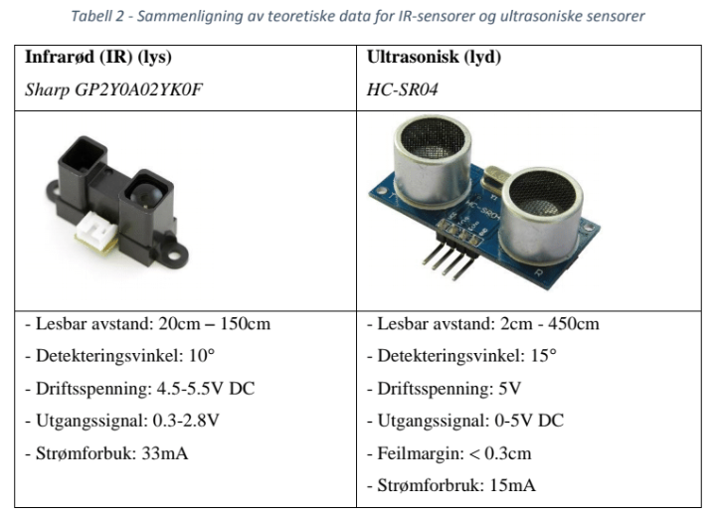

From the specifications of the sensors it became apparent that the ultrasonic sensors were best suited for the project, as it was assumed that distances were needed over 150cm from the agent.

While the IR sensor from Sharp (GP2Y0A02YK0F) has a very narrow detection angle and a readable range of between 20cm and 150cm, the HC-SR04 has a longer range (2-400cm) and a slightly larger detection angle. Articles and pictures from similar projects also described that the latter sensor could have an even greater detection angle than that specified and that this type of sensor is usually used. To avoid dead zones, near the agent or between the sensors, it was chosen to use the HC-SR04 ultrasonic sensors.

**3.1.2.2 Testing of sensors**

Thus, 10 ultrasonic HC-SR04 sensors were purchased before testing of the sensors was started, with particular focus on readable distance, error margin and detection angle.

The testing was carried out by loosening sheets of sheets to cover a sector of about 90 ° (Figures 3-10). This sector was again divided into smaller sectors, each at 10 degrees, as well as the mark for every tenth centimeter from the sector's starting point. Then the car was mounted on a sensor 80mm from the ground and placed in this point (Figure 3-11). A program that continuously read and printed sensor measurements in the Arduino serial monitor was added to an Arduino UNO so that it was possible to observe the results.

----------------------------------------------------------------------------------38p---------------------

The measurements were made by inserting a cardboard box along the arc of the various distances from the sector's starting point. The point where the sensor first showed a stable distance measurement to the box was marked on the sheet together with any deviations.

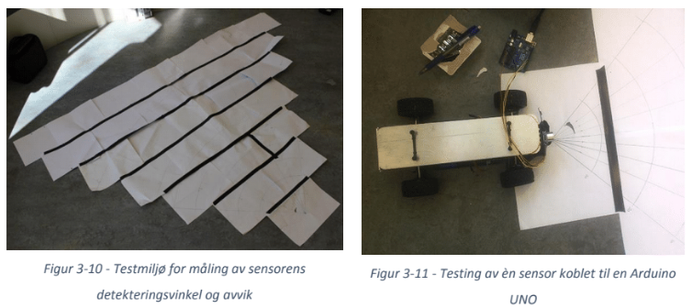

Figures 3-12 show the result of the test. The sensor provided stable measurements in a sector of 50 ° -60 ° between 10cm and 100cm from the sensor. Up to 70cm from the sensor was read a deviation of up to three centimeters (about 4%) at each point. At 100cm from the sensor, however, the deviation increased to eight centimeters (8%). For exact readings, refer to Table 3. The test results showed that the sensor had a larger detection angle, but higher deviation than what was stated.

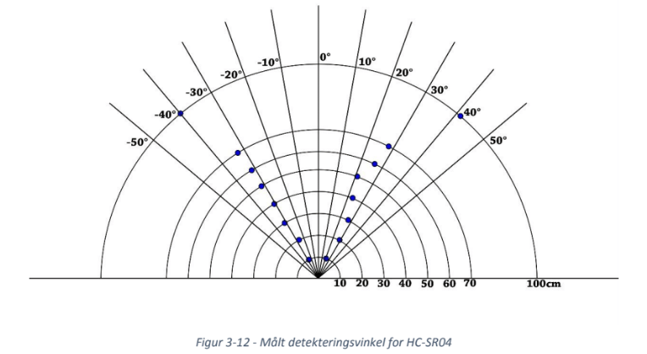

------------------------------------------------------------------------------------------------------------------------------39p---

#문서 번역 – 40p~59p

*Table 3 - Measured deviations and detection angle for HC-SR04*

|  |  |  |  |  |
| --- | --- | --- | --- | --- |
| **read measurement**  **from the left [cm]** | **detecting**  **angle left [ °]** | **Distance**  **[Cm]** | **detecting**  **angle right [ °]** | **Read measurement from right[cm]** |
| **10** | **-28** | **10** | **20** | **12.8** |
| **22** | **-28** | **20** | **28** | **21** |
| **33** | **-32** | **30** | **27.5** | **30-31** |
| **42-43** | **-30.5** | **40** | **23** | **40-42** |
| **52** | **-32** | **50** | **20.5** | **49-51** |
| **60** | **-32** | **60** | **26** | **59-60** |
| **71-72** | **-33** | **70** | **28** | **71-72** |
| **98-104** | **-40** | **100** | **41** | **98-106** |

*3.1.2.3 Behaviors*

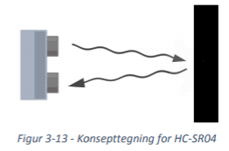A human ear can hear frequencies of 20Hz-20kHz.

Ultrasonic sound, however, in the non-audible with shorter sound waves (40kHz). An 4ultrasonic sensor consists of a speaker and a microphone. The speaker emits a sound wave, while the microphone listens for the echo of the sound (Figure 3-13).

**(Concept art for HC-SR04)**

Based on the time of sound is reflected and received, a distance is calculated, since it is known that the sound of the air moving 340 meters per second. To get the distance between sensor and object must currently be divided in two, as the sound must move both forward and back. The formula is then:

Distance= (measured time * the speed of sound) / 2

(14)

The timing diagram for HC-SR04 is shown below (Figure 3-14). To start a measurement must be given a 10us long pulse to the trigger input of the sensor. This allows the module sends out eight cycles of ultrasound at 40kHz while putting echo output high. When the echo of the eight cycles received, set echo output again low. In 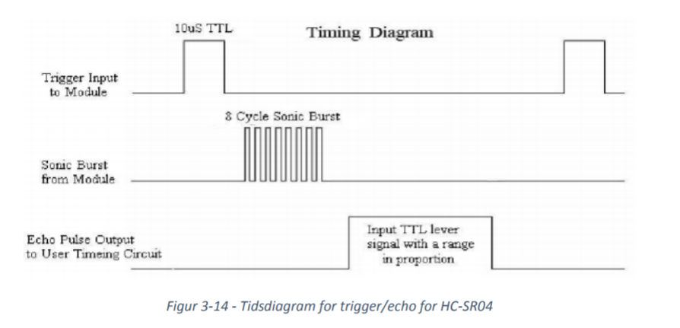this way, the echo pulse width proportional to the distance.

(*Figure 3-14 - Timing chart for trigger / echo HC-SR04)*

*3.1.2.4 Microcontroller*

As the project's goal was to develop a self-learning algorithm and a study area of autonomous systems, was focused on keeping the electronics as simple as possible. The project has utilized Arduino, which is a very proven and well documented platform for prototyping of electronics. their model Arduino UNO R3 is a microcontroller card 14 digital inputs and outputs as well as six analog inputs. On the microcontroller is a part finished libraries to simplify programming for connection of such sensors and the Bluetooth module used in this project.

Table 4 shows the pin configuration for microcontroller card used in this project. Figure 3-15 is intended as an illustration of the data from the same table.

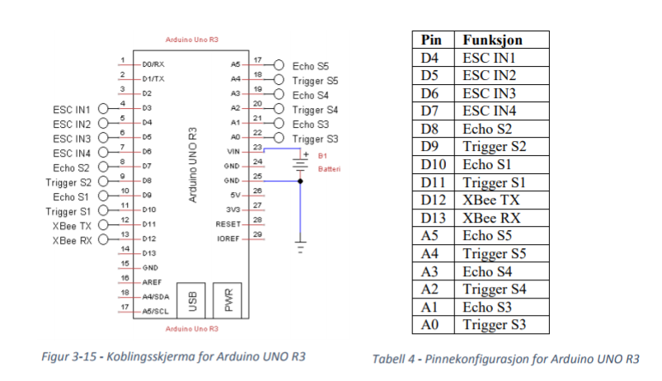

(*Figure 3-15 - Connect screen Arduino UNO R3) / (Table 4 - Pin Configuration Arduino UNO R3)*

*3.1.2.5 Electronic Components*

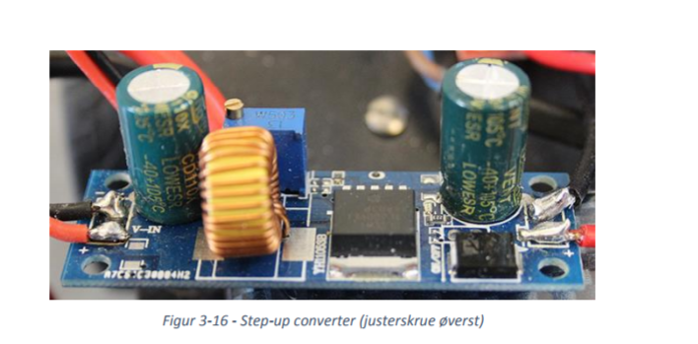Agent engines central Zheng ZGB37RG17 was designed for 24 volts. With a battery of 7.4V was Therefore, an DC step-up converter (Figure 3-16) to give the motors correct voltage. One step-up converter may have a low input voltage (4,5-32V) then and output a higher output voltage (5-42V). The output voltage is adjusted by changing a variable resistance. Using this adjustability could the agent's maximum speed both changed analog and through programming. Was selected voltage of approximately 9V, which gave the agent a rate of about 3 km / h.

*Figure 3-16 - Step-up converter (adjust screw top)*

Arduino UNO has only a certain number of inputs and outputs in addition to a current limit of 20mA per output. Each sensor is connected via four lines (GND, + 5V, trigger, echo). With five sensors were this alone 20 inputs and outputs. To reduce the number of wires to the microcontroller was therefore specific holding GND and + 5V outside Arduino card on a separate PCB by adjusting battery voltage down to 5V.

Regulator step (wiring diagram: Figure 3-17 PCB: Figure 3-18) consists of a five volt voltage regulator (LM7805), three capacitors (100uF, 10uF, 100nF) and an LED to indicate whether card is energized. Trigger and echo are included on the card to have screw terminals for all connecting wires and simplify any replacements of faulty sensors.

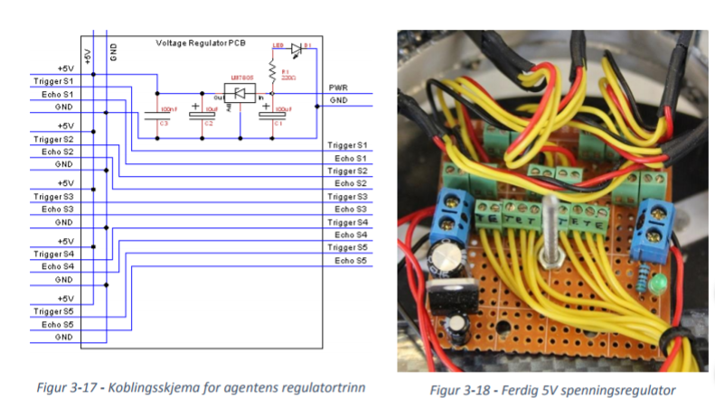

*Figure 3-17 - Wiring for the agent regulator stage / Figure 3-18 - Done 5V voltage regulator*

Motor driver (Figure 3-20) selected is based on a dual H-bridge (English: H-bridge), such as L298N. Motor driver has four outputs of the two engines (1, 2, 3, 4), three inputs for supply voltage (12V, GND, 5V), and six inputs used to set the direction of the motors. Two of these inputs are the Enable A and Enable B. These set high (+ 5V) to turn on each of the two motor outputs. The last four inputs are IN1, IN2, IN3, IN4. Logical table motor driver both motor 1 and motor 2 is shown in Table 5 and Table 6. IN1 and IN2 controls the direction of motor 1, while IN3 and IN4 controls similarly motor 2. Figure 3-19 shows circuit diagram of the card.

*Table 5 - Predictive table motor driver L298N dual H-bridge motor 1*

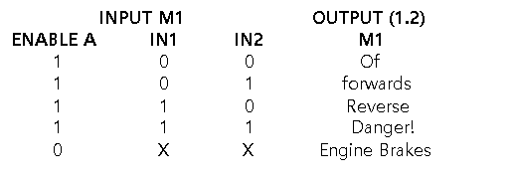

*Table 6 - Logical table motor driver L298N dual H-bridge motor 2*

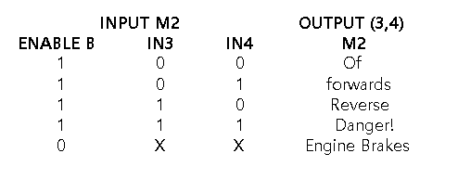

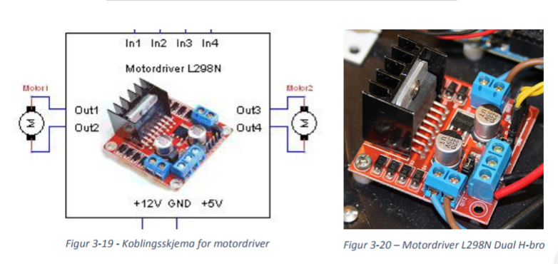

*Figure 3-19 - Wiring motor driver / Figure 3-20 - Motor Driver L298N dual H-bridge*

3.2 The arena

*Figure 3-21 - Picture of the arena*

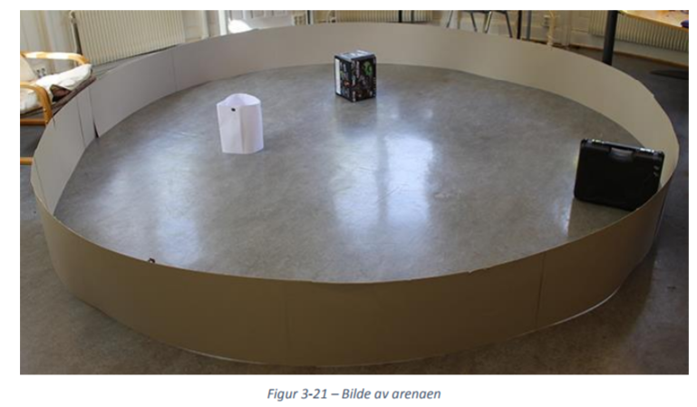

Arena walls (Figure 3-21) is built in 1mm binder cardboard. The cardboard was delivered seven sheets of 70x100cm as was divided lengthwise, and then be stapled together. The 14 sheets were stapled together anytime and anywhere except for one to be able to vary the arena size. Maximum size is a circumference of about 14 meters, or a diameter of about 4 meters. The arena size is varied by changing the degree of overlap in transition where the cardboard is not stapled together.

3.2.1 Dynamic obstacles

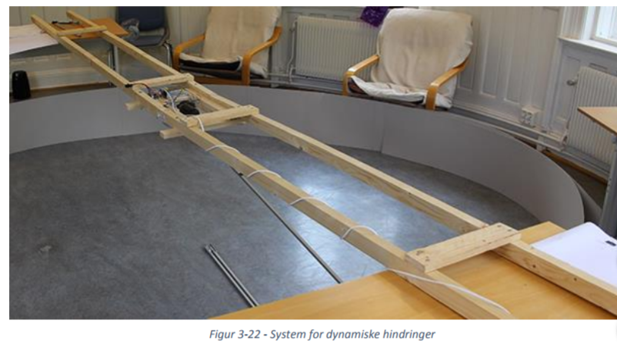To demonstrate the car's ability to adapt to a changing environment had to build a system where the number of obstacles could change and the rate and pattern of these, could be changed. To limit the complexity of the system, the starting point in a rotating obstacle. Hurdle would rotate about a slow speed shaft 1.5 meters long square tube of aluminum mounted so that the obstacles could hanging from them. The requirements were that the angle between the arms and the distance from the shaft to the obstacle could varied when the system was shut down. This is to introduce the car for new patterns.

*Figure 3-22 - System for dynamic obstacles*

Hurdle rate was important. The system's rotational speed was believed to have could be varied with a rate from 0 to 30 r / min, either manually via a potentiometer, or preprogrammed sequence via a microcontroller. During testing, it was found out that the voltage motor may have before the started to rotate changed based on the weight of the number of obstacles system should rotate, and therefore was easier to perform start and speed control manually via a potentiometer rather than a hardcoded program.

A DC motor loses torque at low revs. A geared motor was therefore necessary to rotate all hurdles at low speed. A geared motor is a motor with a gear or exchange coupled between the motor shaft and the output shaft. This allows the output shaft holds a lower speed with a higher torque.

A wiper motor available rotation speed of 300 r / min was obtained. There was a need for very low rotational speed and as the lowest adjustable speed motor gave too low torque, was therefore made an exchange of 1 / 12.5 to reduce speed and increase torque. The exchange consisting of a rubber wheel with a diameter of 10 cm added until the 8mm thick shaft of the engine. The rotating arms were then linked to the rubber wheel shaft now rotated by 1 / 12.5 of the motor shaft speed. Figure 3-23 shows a picture of the final exchange.

*Figure 3-23 - Picture of motor shaft to rubber wheels*

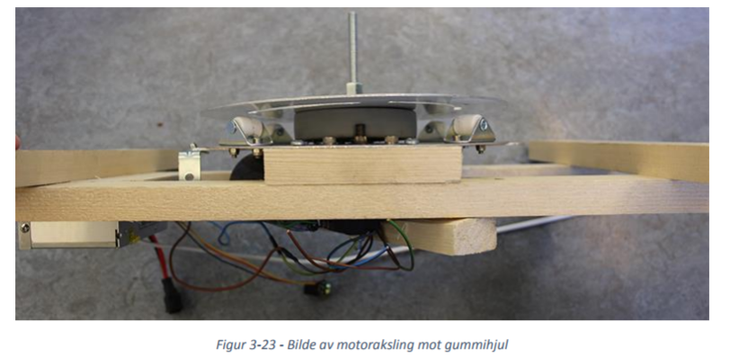

In Fig 3-24 is shown the back of the system of rotating obstacles. The system consists of a motor, a speed regulator and a voltage regulator.

*Figure 3-24 - Overview of electronics for the system of rotating obstacles*

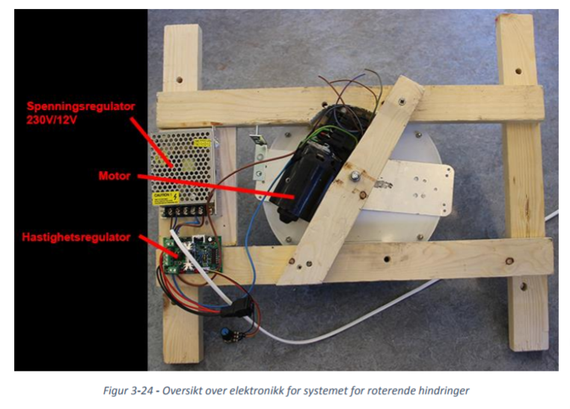

4 System Solution

This chapter deals with the solution of the specific system and describes the implementation method and physics behind demonstrator and simulation. The programming is realized in MATLAB (v2014b) and Arduino (v1.5.6-r2). In MATLAB it is used a function file, SETPROD for kryssmultiplikasjon of vectors and matrices (Ullah, 2006). These versions form the basis for further description of system solution.

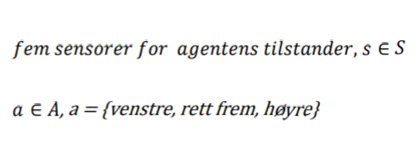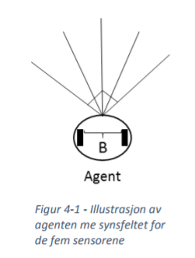

Venstre = left

Rett frem = straightforward

Hoyre = right

*Figure 4-1 - Illustration of Agent Me viewport the five sensors.*

The agent (Figure 4-1) has five ultrasonic sensors that make up state space S in addition to three actions action list A. The angle between the outermost sensors are at 90 degrees. Construction of demonstrator is performed by making a simulation of an agent in MATLAB, and a physical model of the agent. The simulation is intended as a tool for finding optimal values ​​and parameters, and at the same time get an insight into how learning algorithm works. It is also possible to using the simulated values ​​for the physical model, so that a fully trained agent. Agent performance depends on the simulation values, and to what extent these are adapted to the physical model environment.

**Equations used in the simulation algorithm**

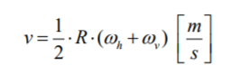Agent's speed:

Where R is the wheel radius.

Wh = Right-hand rotational speed [rad / s]

Wv = Left-hand rotational speed [rad / s]

*Figure 4-2 - Agent's rotation and change*

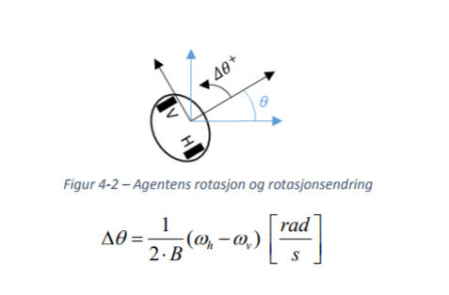

Where B is the distance between the left and right wheels and Θ is the total rotation about the agent's center axis. When the agent is running straight forward rotates both wheels with the same rotational speed. When the agent should change direction is stopped one wheel while the other rotates. We will therefore that:

* Straightforward:
* Right:
* Left:

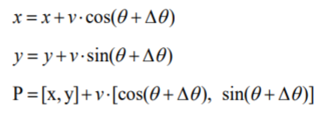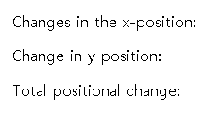

Agent's physics is inspired by (Hatem & Foudil, 2009)

Properties simulated agent, scaled 1:10 [cm]:

- agents radius, radius = 1.0

- The width between the wheels, B = 2*Radius = 2.0

- radius of each wheel, R = 0.325

- Maximum length of the sensors = 10.0

- Collision at the sensor values ​​less than 1.5

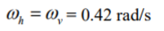- The rotational speed of the wheels when the agent is running straight forward:

- The rotational speed of the wheels when the agent turns:

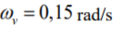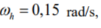or

It is implemented two methods of Q-learning algorithm. The first method is based on the Q-values stored in a lookup table (Q-table), while the second method is to approximate a linear Q function system (neural network).

4.1 Q-learning with table method

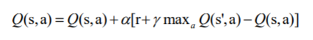This method is based on the theory described in Section 2.2.1. The method uses a table updated as the agent explores its surroundings. At startup, the table is empty, and the agent know nothing other than what condition it is in and what actions it can perform. Equation (1) used for updating the Q-values ​​in this table.

Based on simulation results used $α$ = 0.5 and $γ$ = 0.9 (See simulations of alpha and gamma, ch. 5.2.1). Reward values ​​R (from english: reward) is the immediate value agent gets after a completed action. These values ​​are stored in the table so the agent the next time it achieves the same state can choose to use the action from the previous iteration, if it gave a good reward, or to perform a new action. As the agent over time exploring nearby destinations several times, the table's Q-values converges towards an optimal solution.

*Figure 4-3 - Illustration of the principle Q-learning with table method*

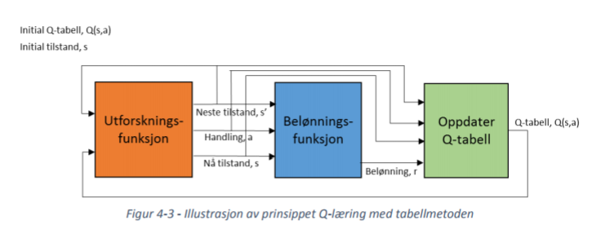

Figure 4-3 shows the agent's learning process in each new state. The principle is that the agent starts in an initial state s, performs an action A and ends up in a new state s’. exploration function determines how the agent discovers its surroundings by determining the extent to which the agent shall use good previously experienced acts or trying a random act in the hope of a better result. Reward function determines the reward for the agent to get the basis of the actions it does in circumstances. Finally updated status table and the process is repeated, but now with s = s'. When agent has reached a terminal condition starts the sequence again with initial state s . At this stage, values ​​from earlier sequences stored in the Q table. Each sequence is defined by the states and actions between each terminal condition, and is referred to as a run (eng .: trial).

The ultrasonic sensors are limited by discretization, the integer values ​​between 1 cm and 120 cm. If one is to create a look-up table for the full range table will consist of 120 five different combinations and would with three possible actions resulted in a lookup table 120 5 * 3 Number seats. This is a less good solution for table would be very large (74 billion seats). A large lookup table causes the agent uses much longer time to learn all of the combinations of conditions and actions for these. Such a solution is also too large to be implemented on a regular computer. This challenge is addressed by discretize, or split up, the continuous the sensing area into smaller, more manageable state space.

4.2 discretization

Discretization of the simulation and the physical agent is somewhat different, since the simulation uses a expanded state space model to treat dynamic obstruction. The extended model is described in Ch. 4.2.1.1 where a comparison of discretization of the physical model and simulation is presented.

The agent perceives the environment around them by means of sensors. Multiple sensors will provide greater accuracy, but will also result in a greater need for processing. The agent is in this case equipped with five sensors, each having a field of view of approximately 60 degrees. The sensors are mounted so that they overlap of about 15 degrees, and the agent thus has a total field of view of approximately 150 °, as illustrated in Figure 4-4.

*Figure 4-4 - Illustration of the agent's field of view*

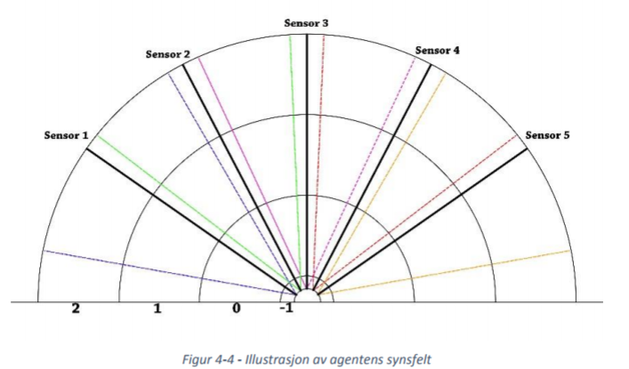

4.2.1 state space

All the sensors can measure distances up to 400 cm. To avoid a large state table and to ef fektivisere learning process, the sensor values discretized down to 144 states. for project

described in this report, this simplifies also reward function.

Each sensor is divided into four zones based on distance in centimeters. The division is shown in Figure 4.4.

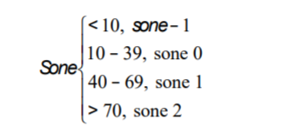

(16)

A state consists of four parameters. Two for the left side and two for the right side of the agent's field of vision. One state is a combination of distance to the nearest obstacle and the sector in which the obstacle is located. A sector describes in what angle an object is located, relative to the agent.

**The four parameters defined by:**

k1: sone left

k2: sone right

k3: sectoral left side

k4: sector right side

k5: observation of dynamic or static obstacle left

k6: observation of dynamic or static obstacle right



* S (state space)

The agent can perceive two obstacles at the same time, but not on the same page. On two obstacles at the same hand algorithm prioritize the obstacle located in the zone with the lowest numbers.

The division of the sectors is illustrated in Figure 4.5.

*Figure 4-5 - Dividing sectors*

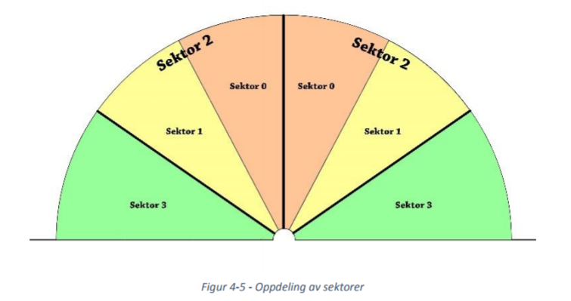

The slices have four different values, 0, 1, 2 and 3. The sensors perceive an object when zone value is less than 2. Sectors are distributed symmetrically, so that the agent's right visual field is discretized in the same manner as for the left. Sensor 1, 2 and 3 on the left side corresponds to the sensor 3, 4 and 5 for the right side.

*4.2.1.1 discretization system with dynamic obstacles*

In the simulation of a system with dynamic obstacles is state space extended with two additional parameters, k5 and k6. k5 indicates with the value 1 or 0 if the obstacle detected at the left hand dynamic, while k6 does the same for the right side. Numeral 1 denotes a dynamic obstacle, while 0 indicates static. Condition Table is with this extended to 576 states. An object is classified as a dynamic obstacle by the agent first, while it is stationary, performs two measurements in succession. Then it compares the two measurements. If the obstacle is moving away from the agent will first measurement drawn from other measurement be a positive number, and classified as a static obstacle. If the same an arithmetic operation on the other hand provides a negative number, classified obstacle as a dynamic obstacle and the agent must respond accordingly.

*4.2.1.2 Condition table*

State table is constructed as a table where all combinations of conditions and actions is represented as a table point. State table for the physical model has 144 rows, and three columns that present each of the possible actions (left, right, straight ahead). A section of status table shown in Table 7.

*Table 7 - Section of status table for static obstacles*

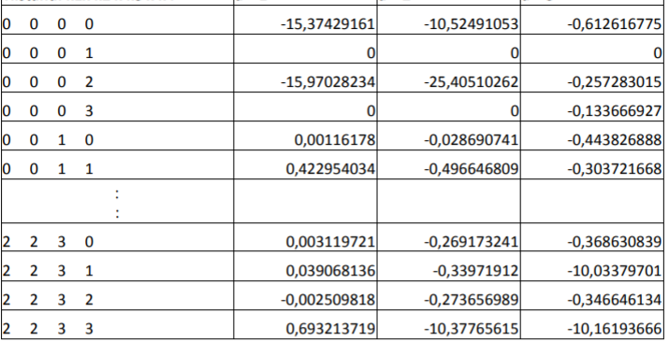**Condition: k1x k2 x k3 x k4** **a = 1** **a = 2 a = 3**

As shown in Table 7, there will be some conditions that are not updated after the agent has completed a longer simulation. In this case, the covering 500 attempts with 400 steps each. The conditions still 0 are conditions that simulated the agent will not be able to reach, as it is designed. By k1x k2 x k3 x k4 = 0 0 0 1, displayed such a condition. This is a condition where the obstacle is located at the head of the right sector (k2 = 0, k4 = 1, see the presentation of the four parameters below Figure 4-3). One reason why Q- values ​​for this condition has not changed, may be that the agent has avoided the obstacles before next zone is visited.

4.2.2 Reward Function

Reward function determines the agent's immediate reward after every experience. By implementation of reward feature distinguishes between good acts as a positive reward value, and bad actions which gives a negative reward value. Reward function used for Q-learning with table method is inspired by (Strauss & Sahin 2008) and shown below equation (17 to 20):

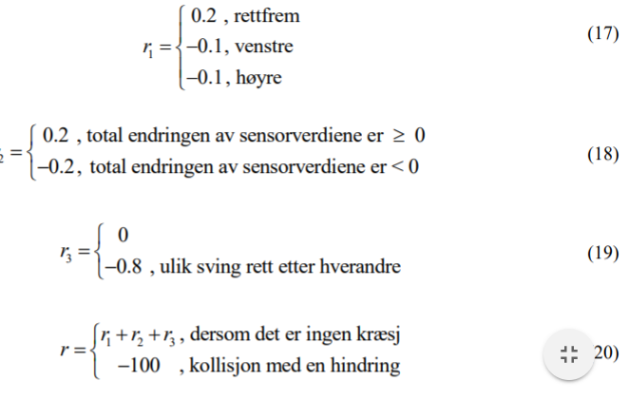Rettfrem = straight forward

Venstre = left

Hoyre = right

0.2, the total change of the sensor values ​​is 0

0.2, the total change of the sensor values ​​is<0

0.8, different pivot consecutively

if there is no crash

collision with an obstacle

From reward function defined R 1 to provide positive reward value when the agent is running straight, whereas for corners is given a small negative reward value. The negative value is given to prioritize driving straight ahead.

The parameter r 2 provides positive reinforcement when the total change in sensor values are positive. I.e agent moves away from an obstacle. If the agent moves against an obstacle, the total change of the sensor values ​​negative, and the agent becomes negative reward.

The function r 3 provides agents negative reward value if the first turns right and then to left, or first to the left and then right successively. This function allows the agent avoids indecisive sequence, where it just swings back and forth.

The function r gives agent a total reward value equal to the sum of r 1 , r 2 and r 3 if it does not collide, while the collision is given a negative reward value of -100.

4.2.3 Exploration Function

Exploration function determines the agent's strategy for selecting actions. It can either explore state space or utilizing experience it already has. The feature ensures an appropriate balance between these strategies (see Sec. 2.3).

The simulations for exploration methods show that softmax performs best in the simulated model, and are thus used in the simulation. The parameter T is set equal to 24, and reduced by 5% of its total value for each attempt. In the physical model used epsilon because it gives a better overview of how great coincidence it is that the agent takes any action, and epsilon is set to 5% chance of do a random act.

4.2.4 Implementation

The implementation of the Q-learning with table method is based on the same algorithm and reward function in the simulation and the physical model. The difference between the simulation and physical agent is exploring the function and an additional expansion of the state room in the simulation (see discretization chapter). In the simulation, we can choose between static and dynamic obstacles and to customize the agent to dynamic obstacles expanded Q-table.

*4.2.4.1 Q-learning algorithm of table method*

At startup:

- Initialize state space S

- Initialize Action List A

- Initialize Q table Q (S, A) (empty table) on the basis of state space S and action list A

For each experiment:

1. Observer initial sensor values
2. Discretization sensor values ​​and set it equal to s (Initial state)
3. Select an action a the basis of exploring the function and perform the action
4. Observe agent sensor values ​​for action
5. Discretization sensor values ​​and set it equal to s (Next-state)
6. Give the agent reward r on the basis of reward function
7. Update Q-table
8. Put s = s' (now state)
9. Keep last action prev_a = a (Nodes reward function)

Repeat the operation from point iii) (a / one new / new step / experience) if the agent does not have reached its terminal condition (collision or the maximum number of steps). Start a new experiment if the agent has reached its terminal condition (Restart from i).

*4.2.4.2 Simulated model*

In the simulation, it is made a user interface showing the user the simulation of the agent, two different graphs, buttons for various functions as well as an information panel. The information panel shows the user relevant values ​​from the simulation. The one graph shows the average number of steps for every ten attempt, while the other shows the agent accumulated reward. One step in the program corresponds to an experienced situation, whether it is experienced before or are new (see Figure 4-3). A new attempt is started each time agent has moved the maximum number of steps for the present experiments, or has collided with an obstacle. Maximum number of steps can be changed, but is normally 400-600. The dimensions of the simulation is scaled 1:10 [cm].

Figure 4-6 shows the user interface MATLAB simulation. The simulation can be used as a Aid to see the agent's learning process, and is used to find the parameters that best fit system. One drawback of the physical model is that the agent must be moved to a non- colliding state every time it collides, while this is done automatically in the simulation. Point (0, 0) in the center of the arena in the simulation are set as the initial state s, and will be the agent's starting point for each new experiment (Figure 4-6).

Algorithm for dynamic obstacles works in the simulation in the same way as for the static. The has the same reward function and exploration function, but the state table for dynamic obstacles are augmented by k5 and k6 (see chap. 4.2.1.1). One obstacle is classified as dynamic if one of the agent's sensors provide a negative change value. In the simulation calculated change value in that the agent is stationary in an iteration, performing two measurements, before the next iteration.

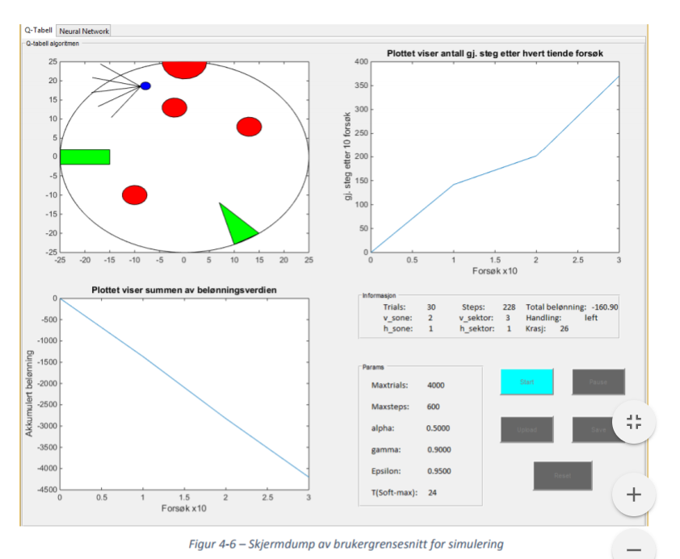*Figure 4-6 - Screen shot of user interfaces for the simulation*

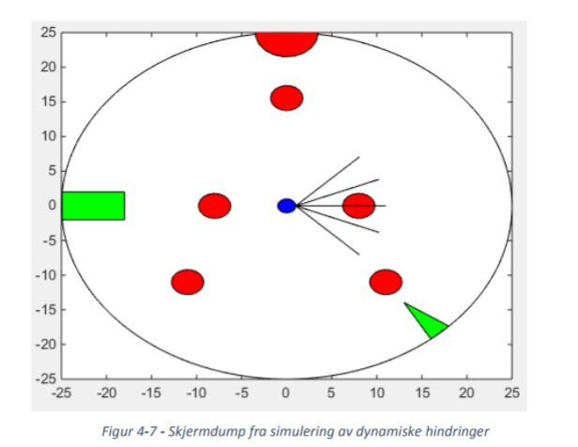*Figure 4-7 - screenshot of simulation of dynamic obstacles*

The dynamic obstacles in the simulation consists of five objects, illustrated by red circles in Figure 4-7, moving in a circular motion. The two innermost obstacles move in one direction, while the three outermost moves in the opposite direction.

*4.2.4.3 Physical model*

Implementation of the physical agent is made with MATLAB and Arduino. The idea is to use MATLAB to make calculations and Arduino to execute commands sent from MATLAB. Communication takes place via Bluetooth.

*Figure 4-8 - Communication between Arduino and MATLAB*

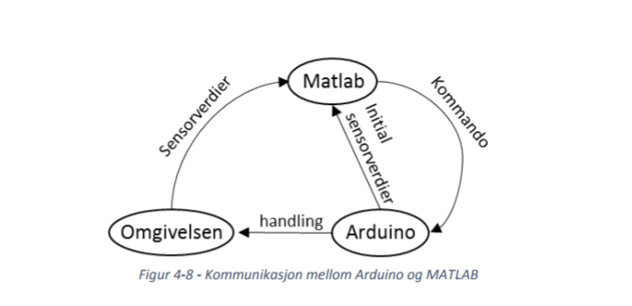

Figure 4-8 illustrates the communication between MATLAB and Arduino. MATLAB transmitter commands Arduino performing these. The learning process is similar to that in Figure 3.4. The ultrasonic sensors on the physical agent is limited to integer values ​​from 1 cm to 120 cm code on the agent's microcontroller. Distance less than 8 cm is defined as a collision. Initial state of the physical agent is an arbitrary position in the surroundings. The only requirement is that initial state is not a terminal condition (collision).

**commands**

- COMMAND 1: Request sensor values

- COMMAND 2: Ask the agent to run straight ahead

- Kommando3: Ask Agent turn right

- Kommando4: Ask the agent turn left

- Kommando5: Ask the agent stop, sensor values ​​<8cm (collision)

4.3 Q-learning with neural networks (linear function approximation)

Q-learning with neural networks are based on approximation of one or more linear Q function. IN Unlike the Q-learning with table stores this method Q function in a neural network. By Using this method is not discretization needed and all the continuous sensor spectrum can be used. The behavior behind an artificial neuron is described in Section 2.3.3.

**Neural network:**

*Figure 4-9 - agents neural network*

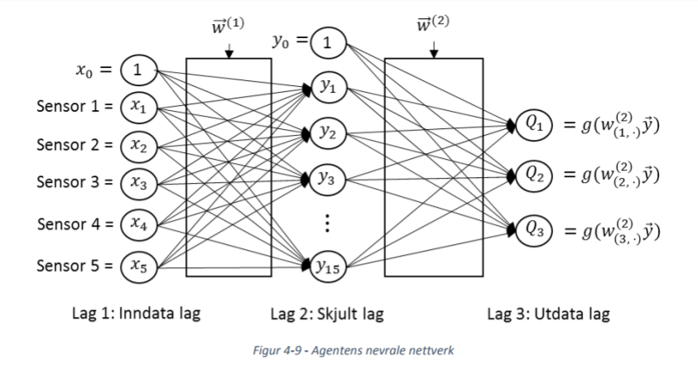

The figure above shows the neural network as implemented in this system. In the network plug all neurons including bias from a layer on to each neuron in the next layer. the neural network has three layers. Create, input layer has five neurons (one for each sensor), approximately two fifteen neurons, and three have three neurons by actions in the action list. Layer 1 is the start of network, and the sensor values ​​are used as input and these must be in the interval [-1,1]. weight matrix

1 is used to weight the link between layer 1 and layer 2, while 2 Layer 2 and layer 3 (See theory).

Arrays have a dimension of (*number of neurons in layer L) x (number of neurons in layer (L-1) + bias)*

1 has a dimension of 15x6 and 2 dimension 3x16. In the output layer, there are three neurons and each single neuron corresponds to a Q function. Number of neurons in the output layer is equal to the number of actions to the agent, and each neuron estimate a Q function with respect to an action of the agent's action list Equation (21).

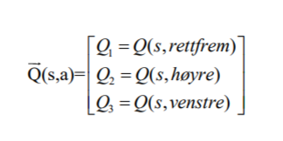

Rettfrem = straight forward

Venstre = left

Hoyre = right

These Q function estimate a Q-value is further used to determine the optimum actions for the agent, wherein the optimum action for each state corresponds to the largest Q function. It optimal action for each state is defined as one *a*= max (Q (s, a)). It is impossible to say the Q-function (s) appropriate for the system, since the neural network estimates the Q function out the basis of the agent's experiences. For the agent to achieve the highest total reward, it must therefore explore environment long enough for the network to converge to an optimal function.

*Figure 4-10 - concept art for the agent's learning process NN*

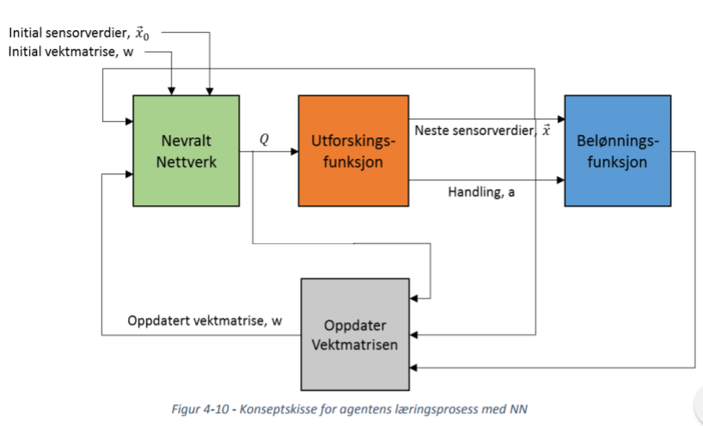

Figure 4-10 shows the learning to the agent. Method needs initial values ​​which are given by sensor values ​​and the network weight matrices. Weight matrix are initialized with random values ​​between 0 and 1, but not zero. If the weight matrix are initialized with a value equal to 0 are all neurons equal value, which means that the neural network is not usable. Figure 4-10 shows that the algorithm uses agent's sensor values, as opposed to table method that uses a discretization of values. Downhill Kings function used is the same as for table method, but the reward function is different. The purpose of this method is to find optimal Q function by updating the weight matrices after each attempt.

4.3.1 Reward Function

As the agent's state space by neural network is continuous, it is not necessary with an equally fuller reward feature for Table method. Reward function is defined by agent gets positive reward if the straight travel, and negative reinforcement for turning and collision. Reward values ​​R must be in the interval [-1,1], and the function as defined for system is shown in Equation (22).

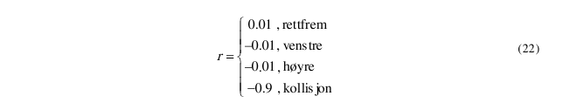The reward function r is inspired by (Huang, Cao & Guo, 2005).

4.3.2 Forward Connected Neighboring Network (Feedforward)

As described in chapter 2 theory, neural networks in this project are a forward-connected neural network.

The neurons are activated using the hyperbolic forceps function given in equation (23).

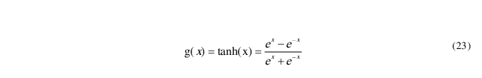.

The enabled values ​​will be output values ​​in this layer, and will be used as input for the next layer. The

The three neurons in the output made correspond to the Q functions when all data is fed to the network.

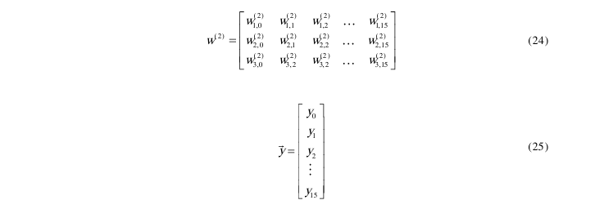

The weight matrix w has the number of rows equal to the number of neurons, and columns n equal to the number of inputs (equation (24)).

Matrix (2)

w and the vector y are multiplied by each other and the product is used in

activation function described earlier in the chapter. The elements in both the weight matrix and

The input vector is real numbers, and the input value is in the range [-1, 1]. Equation (26-28)

shows the Q features of the three actions.

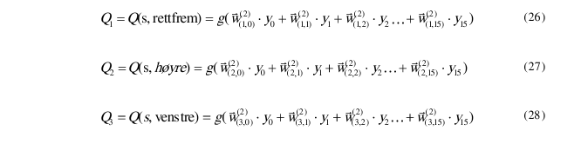

The calculations in the figures above can be shortened and displayed in equation (27) on vector form.

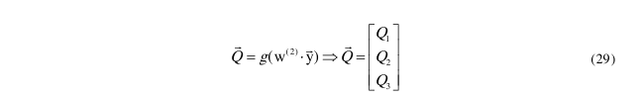

Activation of the hidden layer occurs in the same way as for the output layer, and the input for this layer is sensor values.

4.3.3 Update of weight matrixes

To learn the network, the back-propagation algorithm is used, and

gradient descent. The goal of the back-propagation algorithm is to find

The partial derivative of the function, which is used to update the weight matrix w. In short, goes

learning process minimizes the deviation between the Q functions and the estimated Q value

Neural network wants to achieve, Q_est. This deviation is minimized by finding optimum values

weight matrices. The cost function C is a measure of the difference between the Q function and Q_est.

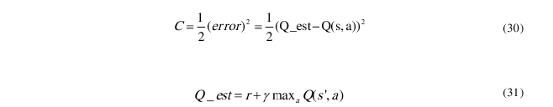

Equation (31) is based on (Huang et al., 2005). Q_est is a real value and a result of the agent

Experience (Equation (29)), and used to train the Neural Network. The gamma parameter has

similar to the table method, and is set equal to 0.9 after simulation in the test results (chapter 5.3.2).

There are several ways to define a cost function, but the function in equation (28) is mathematical

simple and makes the implementation of the function simple. //61p

**Back Reproduction Algorithm:**

The deviations in each neuron are used to calculate the partial derived values. The deviation is called 

Parameter L indicates which layer the deviation is for. The deviation vector has the same dimension as the number

neurons + bias for layer L. The algorithm starts in the last team and works backwards in the network.

Formula 1-10 shows the equation for deviation calculation in the output layer.

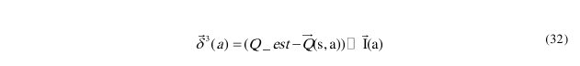

The vector  is the Q values ​​from the neural network. When calculating the deviation, only the Q value corresponding to the most recent operation is taken into account.  is an identity matrix where  refers to each column for the different actions in the identity matrix.

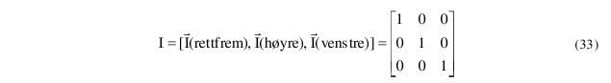

Formula 12-1 shows if a = right becomes the deviation vector in the output layer

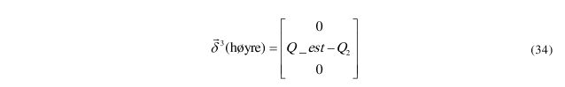

The reason that the deviation vector is multiplied by the unit vector in layer 3 is to avoid error estimations of the other Q features. After calculating the deviation vector , it is returned to the previous layer 2, 3  to find the deviation vector in that layer. Calculation of the deviation vector  in layer 2 is shown in equation (35).

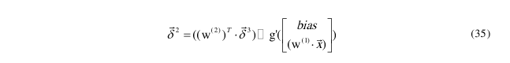

 is the transposed weight matrix for the weights between layer 2 and layer 3 (see Figures 4-9). The transposed matrix is ​​multiplied by the error vector from layer 3.The matrix  has a dimension 3x16, and  therefore get a dimension of 16x3. The deviation vector  has the dimension 3x1. //62p

The product between the weight matrix and the deviation vector  becomes a vector of dimension 16x1 (equal to dimension ). The vector is further elementally multiplied by the derivative of the activation function. Equation (36) shows the derivation of g.



The matrix  is the weight matrix for the link between layer 1 and layer 2 and has a dimension of 15x6. The vector  is the inputs +  (bias) in layer 1. The dimension of the vector  is 6x1. Multiplication of the matrix  and the vector  gives a vector of dimension 15x1 which is not equal to the dimension in the expression 

This is solved by adding bias = 1, and the vectors get equal dimensions.

Team 1 receives sensor values ​​as input. Because the sensor values ​​are not estimated values ​​from neurons, there is no deviation vector . After finding all the  vectors with the back-propagation algorithm, the deviation vectors are further used to find the part-derived values ​​with respect to the weight matrixes  and 

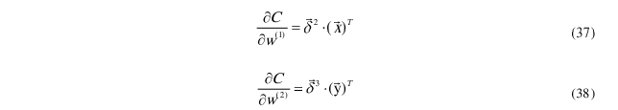

The part-derived values ​​are used to update the weight matrices, and this is done by the algorithm gradient descent. The back propagation algorithm is based on (Ng et al., 2015). //63p

**Gradient Descent:**

The algorithm gradient descent is used to update the weight matrices with the partial-derived values. The algorithm's goal is to find a local minimum that causes costing to go to zero.

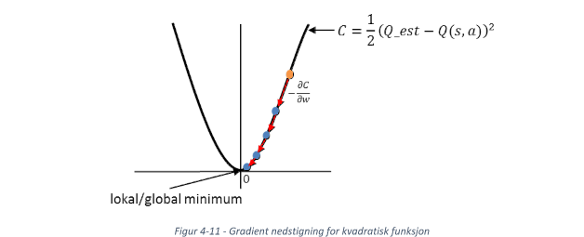

<Figure 4-11 Gradient descent for square function>

Figure 4-11 illustrates a gradient descent for a cost function. The red arrows in the figure show each step for the gradient descent algorithm. The algorithm approaches a local minimum by many steps. After calculating the gradient of the cost function 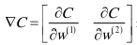 with the back propagation algorithm,  is used to update the weight matrix in the neural network. The update of the weight matrixes is shown in equation (39-40).

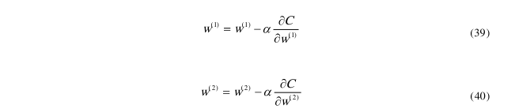

The alpha parameter is the learning rate of the algorithm and determines the size of the descent algorithm must move by step. The result in Chapter 5.3.1 shows that alpha = 0.03 gives the best results for this system. This learning rate is the same as the learning rate in formula 1-1 for the Q-learning method. The solution of The gradient descent algorithm is based on (2.5 - Gradient Descent - [Machine Learning] City Andrew Ng, 2014). //64p

**4.3.4 Mode of action**

The structure of the algorithm is based on Figures 4-9, Figures 4-10 and Chapter 4.3. The flow chart for the program is in Appendix C.

**4.3.4.1 Neutral Network Q Learning:**

The behavior of the neural network algorithm is discussed in the sections below.

Before start:

-Enter the size of the neural network (5 neurons in layer 1, 15 neurons in layers 2 and 3 neurons in layer 3).

-Initialize the weight matrices and with random values ​​between 0 and 1

For each attempt:

i) Observe the agent's sensor values

ii) Estimate the Q functions with forward switching in the agent's neural network

Iii) Select an action a with the exploration function and complete the action

iv) Observe the agent's sensor values ​​after performing the action

v) Give the agent the reward r with the reward function

vi) Estimate the Q functions with forward switching

vii) Estimer Q_est

viii) Calculate partial derived 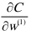 and 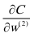 with the re-propagation algorithm

ix) Update the weight matrices  and  with the gradient descent algorithm

x) Repeat the algorithm from point iii). If the agent has not reached its terminal condition (collision or max step) a new step is started. If terminal mode is reached, start algorithm again from point i).

The user interface for the simulation of Q-learning with neural networks and the table method is quite similar.

Implementation is completely similar to systems with static and dynamic barriers. //65p,66p

**5 Result**

**5.1 Procedure for simulation**

All the tests in the chapter are based on simulations. Simulations are used because it is time-saving and easier to see development over time for different methods and parameters. The tests are done in a certain order, as different methods and parameters depend on each other. In cases where it is necessary for subsequent testing, conclusions will be drawn as to which methods or parameters work best.

The order of the simulations is given chronologically in the diagram chart (Table 8). The methods are listed in the table as Q (Table Method) and NN (Neutral Network).

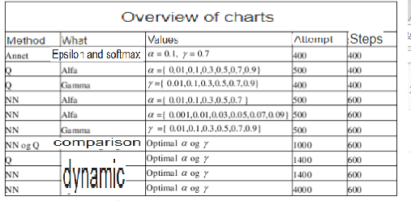

<Table 8 - Overview of charts in results>

The simulator is made as physical as the physical demonstrator, but differs from it at the following points:

1. The simulation is based on sensors that see a straight line, a given length and direction relative to the car. The sensors in the physical model perceive objects in an area, and the ability to perceive an object also depends on the relative angle between the agent and the object. In some cases, it leads to incorrect metering values.

2. Simulation detects when the agent's body crashes with objects, but this gives no negative reward. The demonstrator does not detect this type of crash since it does not have sensors on the sides and back.

3. Simulation speed is determined by processor capacity, and drives so fast that the agent can measure twice right after each other without perceiving or giving any consequences. Two measurements are used to determine if an object is dynamic or static. In the physical model, it is not possible due to time delay in electronics and communication, as well as physics.

//67p

The results show the principle behind the method and the values ​​presented will not necessarily be the most optimal values. Parts of the learning process are based on coincidences, and the results will vary slightly for each test.

An attempt consists of a limited number of steps, and interrupted by achieving the number of steps or collisions.

**5.2 Exploration function**

The graphs in Figure 5-1 compare the two exploration features epsilon and softmax. The value of gamma is set to 0.7, based on the wish that the agent is called long term. Alpha is set after trial and error to 0.1. Both methods are implemented so that they gradually decrease the likelihood of random actions for each attempt. Softmax is implemented at T = 24, and decreases by 5% for each attempt down to T = 0.01. Epsilon is implemented at e = 0.95 and decreases by 2% for each attempt to e = 0.05. Both methods reach this value after 150 attempts.

The test simulates 400 attempts with 400 steps for each method, but the step chart shows points that are an average of every tenth attempt and accumulated reward in the reward chart. This is done to level the graphs and show a trend over the specific points. The results for epsilon and softmax are shown in Figure 5-1 and Figure 5-2.

Total reward and number of steps per attempt are simulated for both epsilon and softmax. Figure 5-1 shows that softmax converges faster against a solution. Once a possible solution is found, the function continues to use this. Because, after exploration, epsilon still chooses 5% random actions, the agent will not stabilize in the same way as softmax. Softmax has stable 400 increments per attempt after converging into a solution and having higher increments on the accumulated reward graph than epsilon (Figure 5-2). This shows that softmax has found a better solution. Figure 5-2 shows that the system is stable when the reward graph grows steadily. Softmax is assumed to be the basis of the further results. //68p

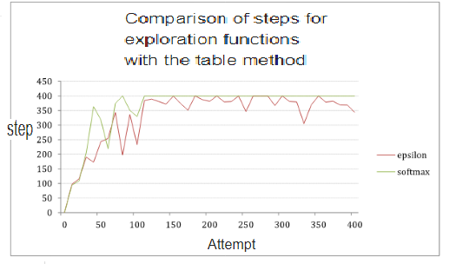

<Figure 5-1 Comparison of the step of exploration function with the table method>

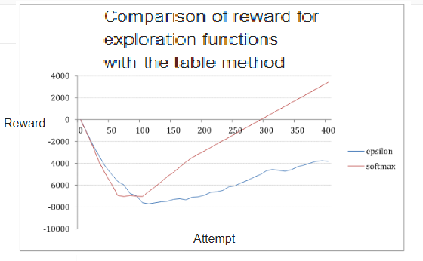

<Figure 5-2 Comparison of reward for exploration features with the table method>

//69p

**5.2.1 Alpha and gamma**

It is desirable that the agent is long-term as it does not have any terminal and the system is to be simulated for a long time. Therefore, gamma is set to 0.9, and simulations for seven different values ​​of alpha are shown in Figure 5-3. The simulation was done over 400 steps and 500 attempts for each alpha value. The graphs in Figure 5-3 show an average of three tests to smooth out randomness in the measurements and show a trend over single measurements. The alpha and gamma parameters affect each other, but for this project, a static gamma has been set up to have a system that prioritizes actions in the future.

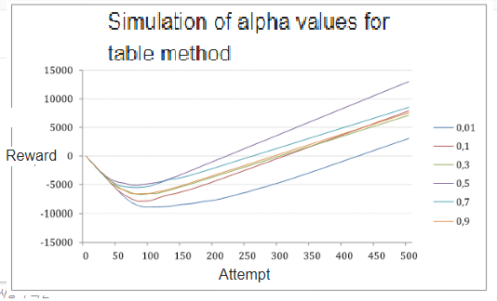

< Figure 5-3 Simulation of alpha values ​​for the table method>

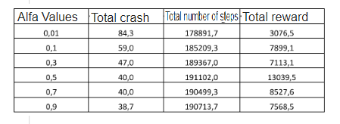

<Table 9 Result from simulation of alpha values ​​for the table method>

Table 9 shows the total number of crashes, total number of steps and total reward value based on the average of three tests. Based on the table and Figure 5-3, 0.5 is the alpha value that gives the best reward and the highest number of steps. For further testing using the table method, alpha 0.5 is used. //70p

Gamma values ​​were simulated by the same procedure as for alpha, but with alpha set to 0.5. Figures 5-4 show overall reward for the various gamma values. The graphs in Figure 5-4 show the average of three measurements for each gamma value.

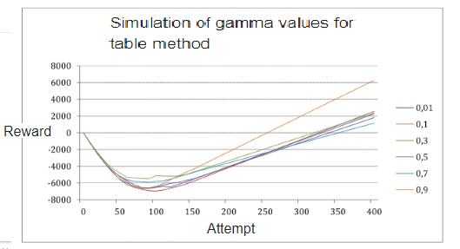

<Figure 5-4 Simulation of gamma values ​​for the table method>

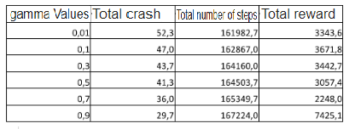  
<table 10 Results from simulation of gamma values ​​for the table method>

Table 10 shows an overview of the total number of crashes, total number of steps and total reward value for the various gamma values ​​in the simulation. In this system, gamma 0.9 is the value that gives the highest total reward, the lowest number of crashes and the total number of counts. The graph of gamma 0.3 has a higher minimum point in the reward value than gamma 0.9, but a lower gradient. As a basis for further testing, gamma 0.9 is therefore used. //71p

**5.3 Neutral networks**

**5.3.1 Alfa**

The graphs in Figure 5-5 show total reward for the various values ​​of alpha. The simulation is realized using a neural network. Gamma is set to 0.9 for the same reason as for Q learning, and the simulation is for 600 steps and 500 attempts. It is necessary to do more accurate testing to verify that the result is not 0. A result of 0 means that the system does not acquire new knowledge. Figures 5-6 show simulation for alpha values ​​near the best value from test 1 that became 0.01.

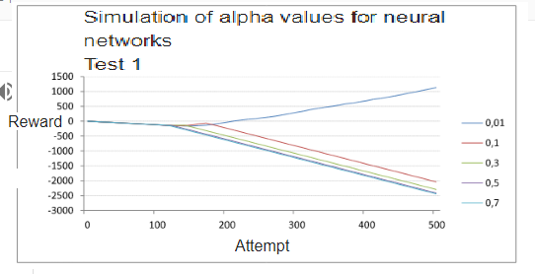

<Figure 5-5 Simulation of Alpha Values ​​for Neural Network (Test 1)>

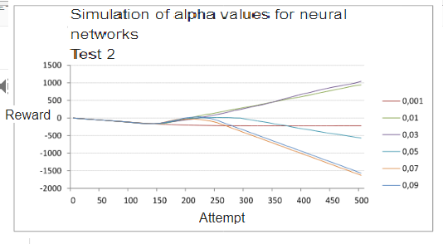

<Figure 5-6 Simulation of Alpha Values ​​for Neural Network (Test 2)> //72p

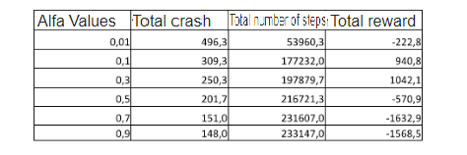

<Table 11 Results from simulation of alpha values ​​for neural networks>

Table 11 shows an overview of the total crash, total number of steps and total reward value for the various alpha values ​​based on the average of three tests. Three measurements have been made to level the graphs By simulation (Figure 5-6) for the given number of steps and attempts, 0.3 is the value that gives the greatest total reward. It is not the value that gives the first number of crashes or the most steps, but for the practical purpose, the increase in the reward value and the reward value are crucial for the choice of value. Further simulation of gamma values ​​assumes a given alpha value. For further testing, alpha 0.3 is therefore used.

**5.3.2 Gamma**

Figures 5-7 show a simulation for different gamma values. The test is simulated with 600 steps and 500 attempts. Table 12 shows an overview of the total number of crashes, total number of steps and overall reward for the various gamma values.

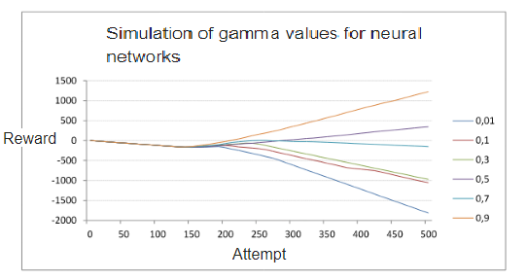

<Figure 5-7 Total reward Q for different values ​​of Gamma for Neural Network> //73p

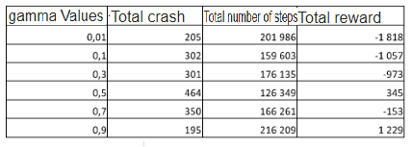  
<Table 12 Results from simulation of gamma values ​​for neural networks>

**5.3.3 Comparison**

Table 13 shows the total number of crashes and total number of steps for the table method and neural network. Figure 5-8 compares the two methods based on the number of steps per attempt. Best values ​​for alpha (0.5, 0.03 / Q-table, neural network) and gamma (0.9, 0.9 / table method, neural network) for both methods are used in the simulation. Neutral networks and the table method are implemented with various reward features. The reward features and the difference between these are described in more detail in Chapter 4.5. The accumulated reward simulations for the two methods are shown in two different shapes (5-9 and 5-10) to improve readability.

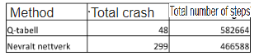

<Table 13 Results from simulation of comparison of table method and neural network> //74p

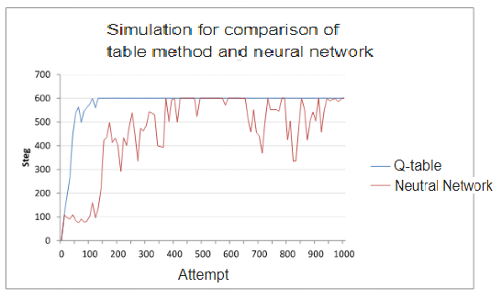

<Figure 5-8 Simulation for comparison of the table method and neural network>

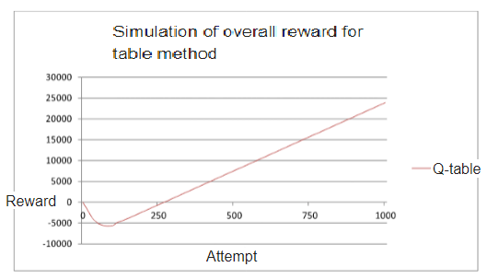  
<Figure 5-9 Simulation of overall reward for the table method> //75p

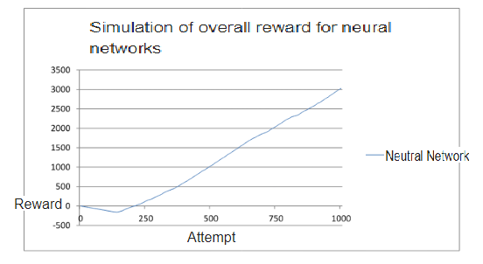

<Figure 5-10 Simulation of overall reward for neural networks>

Figures 5-11 show the sum of the cost function for each of the three Q functions in neural networks. Best values ​​for alpha (0.3) and gamma (0.9) are used in the simulation run 1000 attempts. The black graph in Figures 5-11 shows an average of 25 attempts to illustrate a trend rather than single measurements.

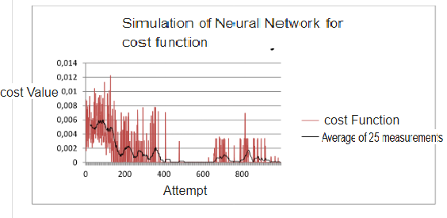

<Figure 5-11 Simulation of cost function for neural network> //76p

**5.4 Simulation of systems with dynamic barriers**

The tests are performed with objects that rotate in the same direction at constant speed. After 800 attempts, the direction of the rotating obstacles changes. The simulation is run with 500 steps and 1400 attempts for both methods. Table 13 shows an overview of the total number of crashes and the total number of steps. Figures 5-12 and 5-13 show simulation of the number of steps and accumulate t reward for Q-table, while Figures 5-14 and 5-15 show the same for neural networks. Same values ​​for alpha and gamma as presented in chapter 5.3.4 are used for simulation.

Figures 5-16 show the sum of the cost function for each of the three Q functions in the neural network. The black graph in Figures 5-16 shows an average of 25 attempts to illustrate a trend rather than single measurements.

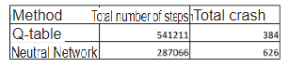  
<Table 14 Overview of total values ​​for dynamic simulation>

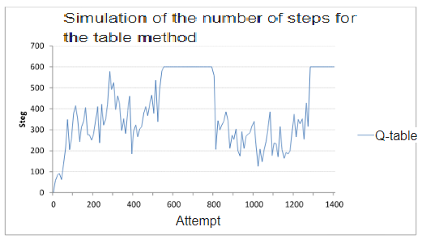  
<Figure 5-12 Simulation of the number of steps for the table method> //77p

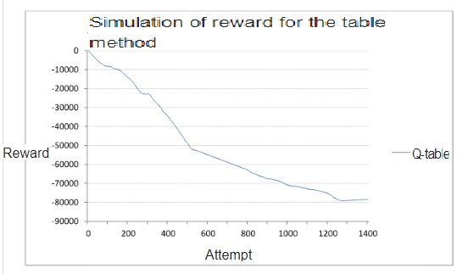  
<Figure 5-13 Simulation of reward for the table method>

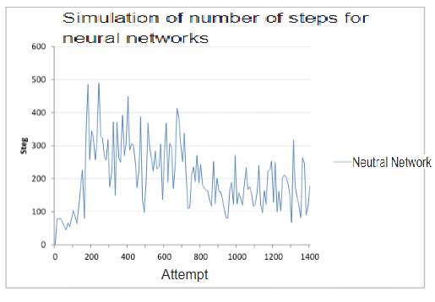

<Figure 5-14 Simulation of number of steps for neural networks> //78p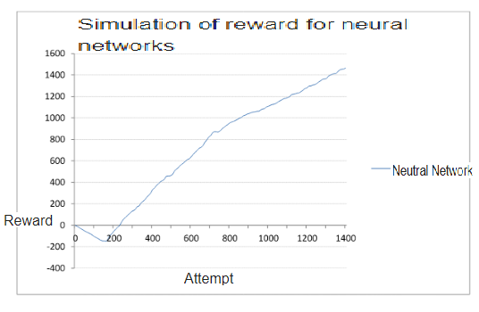

<Figure 5-15 Simulation of reward for neural networks>

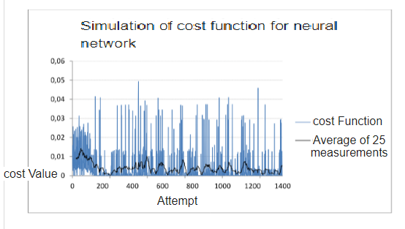

<Figure 5-16 Simulation of cost function for neural network> //79p

Simulation of Accumulated Reward (Figure 5-17), Total Number of Steps (Figure 5-18) and Cost Function (Figure 5-19) of Neutral Networks with Dynamic Obstacles are included to determine if the system converges into a solution. The simulation is done over 4000 attempts to see if the Neutral Network finds a stable solution during more attempts than for other simulations.

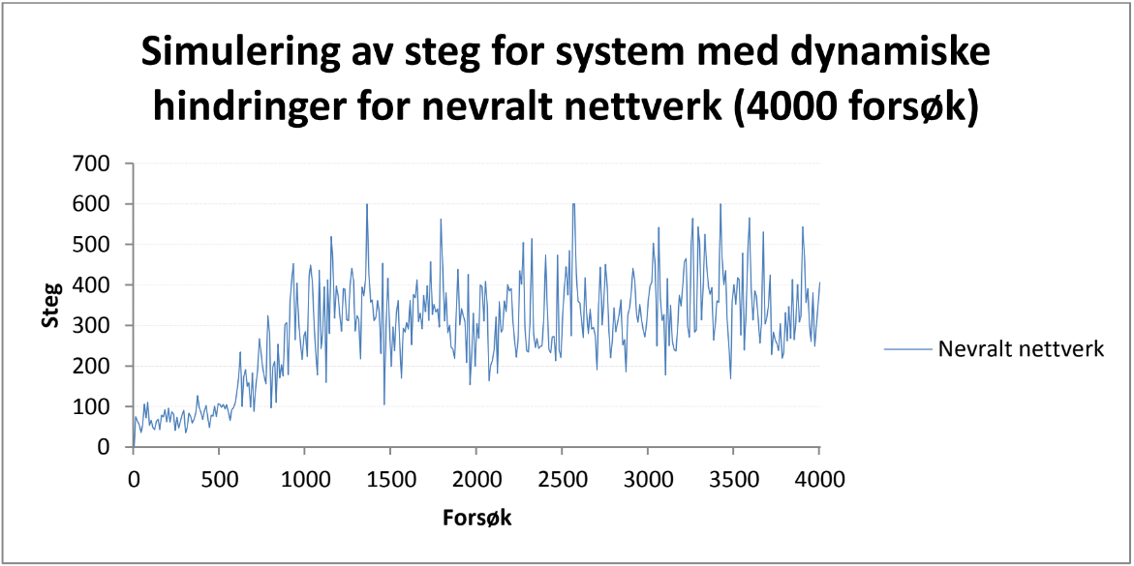

Step

Attempt

Neural network

**Simulation of steps for system with dynamic barriers for neural networks (4000 attempts)**

Figure 5-17 - Simulation of steps for system with dynamic barriers for neural networks (4000 attempts)

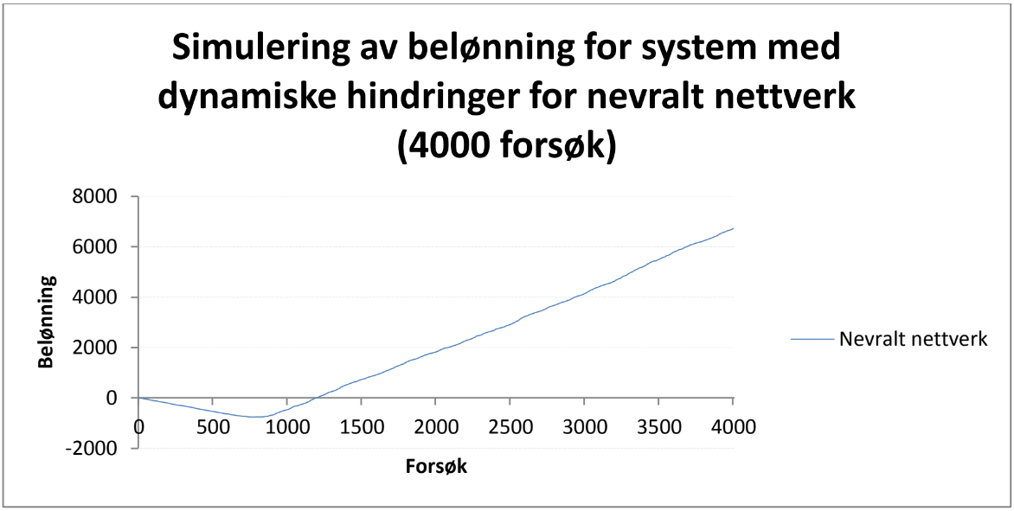

Reward

Attempt

Neural network

**Simulation of reward for system with**

**dynamic barriers for neural networks**

**(4000 attempts)**

Figure 5-18 - Simulation of Reward for Dynamic Barrier System for NN (4000 Attempts)

----------------------------------------------------------------------------------------------------------------------80p

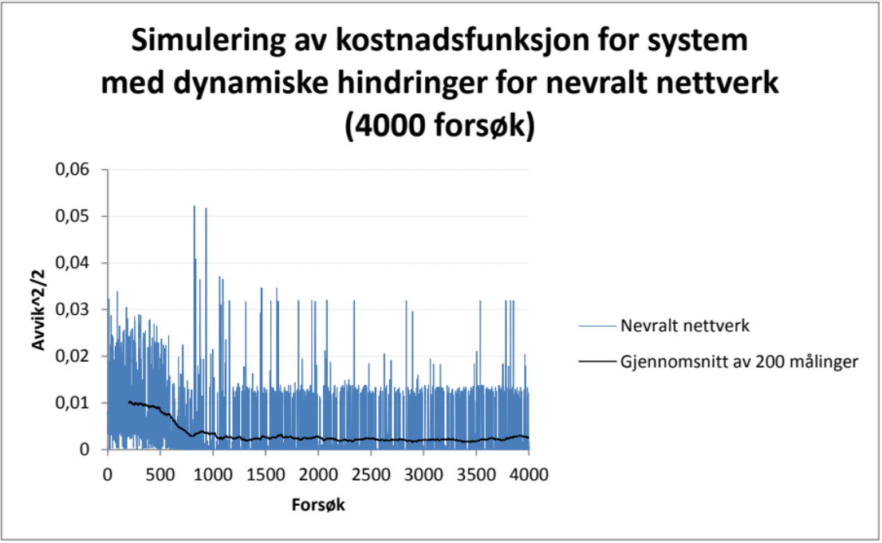

Deviation ^ 2/2

Attempt

Average of 200 measurements

Neural network

**Simulation of cost function for system**

**with dynamic barriers for neural networks**

**(4000 attempts)**

Figure 5-19 - Simulation of cost function for system with dynamic barriers for NN (4000 attempts)

----------------------------------------------------------------------------------------------------------------------81p

----------------------------------------------------------------------------------------------------------------------82p

6 Discussions

6.1 Comparison of demonstrator and simulation

The simulation is made as equal as possible the actual conditions agent would meet in the physical arena.

The size of the arena and the agent in the simulation is proportional to the ratio of the physical demonstrator. Yet there are some elements, such as friction and power constraints, that allows the two systems are different. In the simulation the system is speed limited only by computer resources. In demonstrator comes to a speed where the agent will lost it the roadway or situations in which the agent will run for far between each sensor measurement. the physical model is limited by battery capacity, unlike the simulation will run as long as there is access to electricity.

A concrete example of an inequality is the solution for dynamic obstacles in the two models. This best illustrated by first describing the simulation, and then compare it with the physical model. A program carried out sequentially. That is one function executed at a time, but often so fast that it feels as if everything is happening simultaneously. The agent must react earlier to avoid dynamic obstacles towards it, than the need for static. To determine if an obstacle is in motion or static stopped agent. This is followed by two measurements. Based on the distance has increased, is reduced or unchanged on the two measurements the agent separating moving before it moves further and the process is repeated. The simulation is perceived anyway as seamless because this sequence is done many times a second. In the physical model would same procedure probably worked just as well, but agent's motion would have been characterized by continuously start and stop.

As soon as the man is introduced into a system will inaccuracy be a fact. Human movements are not as repeatable and accurate as that of a computer. During the course of the project has been made a demonstration video (provided on CD) where the agent is placed at an appropriate location in the arena then running against the arena wall and over several attempts to learn to avoid these walls. After each trial moved agent back to the starting point her before it starts the next attempt. In the simulation had this point been exactly the same every time, while in the physical model, this depends on how man places the agent. Location and angle to the wall will probably vary for each time, and with the introduction of the agent for situations other than what was originally intended in the experiment.

6.1.1 Sensors

The agent's five ultrasonic sensors make up its field of view. The sensors are affected by noise and other Factors that make measurements in some situations will give wrong values. The sensor perceives the obstacle when the angle between the agent and the obstacle surface do not exceed +/- 20 ° normal to the agent. In the physical model was in some situations difficult for the agent to perceive obstacles due

----------------------------------------------------------------------------------------------------------------------83p

this factor. Without having conducted tests assumed that the obstacle's surface may have something to say for the ability to reflecting sensor sound waves.

Different frequencies produce different deflection of the sound waves on a surface. One solution to the above problem can thus be either to change frequencies, measuring at multiple frequencies or an entirely different method. Other methods may include cameras, other sensors (e.g., IR) or finished sensor solutions such as Kinect from Microsoft.

Agent's field of view is limited by the five sensors in the front. The agent gets no information about obstacles outside the field of view. This may lead to a collision at the agent turns the obstacle does not appear.

This often appears in the physical model. The problem could be solved by adding more sensors See Further, for example, the rear and side of the agent, but a plurality of sensors results in multiple states (Larger Q-table). This in turn will lead to greater demands on the processing of data.

The sensors in the simulation is technically flawless and gives a direct impact once an obstacle gets in the way, regardless of the angle and surface. The physical factors could to a certain extent been included in the simulation to reduce the differences between the physical and the simulated model.

6.2 Dynamic obstacles

Dynamic obstacles have previously mentioned was challenging in the physical model. The agent looks the distance to the obstacles, but not the direction and speed they have. Because the agent does not know which angle direction obstacle in relation to the agent, it is difficult to say whether it poses a risk of collision.

A conceivable solution would be to make use of the concept of Computer Vision (CV). CV about analyzing and interpreting images through video processing. Using a single camera in front would agent thus seen about as much as it is now doing with the five sensors. as obstacles would not moving from one sector to another, but instead remained in the same picture, it would probably done it easier to say something about the obstacle direction and speed.

Other solutions could be to provide the dynamic obstacles a different color than the static (to distinguish using color sensors), or to equip the obstacles with transmitters informing the agent of the various preventing the positions. On the basis of its own speed and direction would the agent could see a direction obstacles, relative to themselves and do the action that is needed to avoid the obstacle.

Following planning time limit and scope was used ultrasonic sensors. These require, in unlike, for example CV, few resources and training.

----------------------------------------------------------------------------------------------------------------------84p

6.3 Method Options

Timeframe and application of the system is important when the method and parameters to be selected. Some methods require a lot of training to converge to a good solution, while others spend less time to converge to a solution with less potential long term. In most systems require parameters and methods adapted to its use, and the choice has often a compromise between the learning rate, persistence, accuracy and stability.

6.3.1 Error Learning and coincidences

Different choices of parameters also makes different demands on accuracy and stability of a system. A problem that may occur in the physical model because of physical requirements or noise, error learning.

Error Learning occurs when the agent gets reward for actions that are not a good action, or punishment for appropriate action in the given situation. It may take a long time to recover such errors. Physical adaptations are necessary for each system and by discretizing the input can error learning to some extent be avoided. In the simulation will not have this problem occur.

System solutions described in this report will always be influenced by random choice of actions. The is desirable with a system that explores long enough that it converges to the best solution.

The diagrams in the result chapter shows that the development of reward and rose over time will vary with each simulation, and it turns out to be most appropriate to look at the statistics of the total number of coins crash and total rose for evaluation and comparison.

6.3.2 Exploration function and parameter selection

Softmax converge more rapidly to a solution and provides a greater accumulated reward than epsilon (Figure 5-2). It is also the function that provides the most stable values ​​in simulating the number of steps per experiments (Figure 5-1), and is thus the best exploration function for this system.

Simulations for alpha and gamma values ​​are presented in the results section. For table method is not choice of alpha and gamma values ​​critical, and the system will converge to a solution for all valid values ​​(shown in Figure 5-3 and Figure 5-4). The results of neural networks (5.3.1 Alpha and 5.3.2 Gamma) shows that alpha and gamma is essential to find a stable solution.

The results for alpha and gamma is not necessarily optimum values, but the accuracy is considered to be adequate. This is shown through simulation of neural networks, and simulation and functional demonstrator for table method.

----------------------------------------------------------------------------------------------------------------------85p

6.3.3 discretization

Simple and effective categorization of input is important and essential to make a system effectively.

Discretization described in Sec. 4.2 proves to be a good compromise between accuracy and efficiency of the static solution. The system discretization of dynamic obstacles acts, but could be optimized by such discretizing the obstacle or the speed and / or direction.

A dynamic system includes a number of additional factors than static, and therefore has greater requirements precise input and discretization. It is necessary to know the agent and the hurdle rate, in addition to Hinderer direction.

6.3.4 Project results

After exploration period choose methods best experienced acts. The degree of increase in the reward

describe how good the solution is. How smoothly the graph rises or falls, in addition to the total number of steps per experiments, however, show the extent to which the solution is stable. The graph in Figure 5-9 shows that the maximum number of steps for neural network is achieved after about 380 attempts. The method does not retain this solution due to selected structure of the network and selected parameters. Table method converges to a stable solution for 150 trials, and will for this system more quickly reach a stable solution (Figure 5-9). After the agent has found a working solution will not continue to explore the environment that would have meant that it finds second or better solutions. This is a challenge using the table method.

The simulation of the system with dynamic obstacles is completed by obstacles rotate in the same direction and then changing direction after 800 attempts. Simulation shows that table method finds a solution after 400 tries, but this is not optimal as the reward value continuously decreases (Figure 5-12 and Figure 5-13). Neural network finds a solution, but the solution is not stable (Figure 5-14).

Figure 5-16 shows that the cost function does not converge to 0, and the system therefore does not find a stable solution.

Reward The functions of the two methods are different, and to see if the solution is good, you must reward value for the dynamic simulation are compared with the simulation of static for same method.

Simulation of 4000 trials are conducted to see if the neural network converges to a stable solution over time (Figure 5-17, 5-18 and 5-19). The simulation shows that the method during the 4000 trials not find a stable solution. It is believed that a simulation of more than 4,000 experiments will provide the same result, and the problem therefore relates to the method's construction and parameter selection.

----------------------------------------------------------------------------------------------------------------------86p

6.3.5 Further work

As further work in the project, it is natural to make a judgment on whether table method is a suitable solution for a system with dynamic obstacles, or on other solutions, such as fuzzy logic could be worked better. Fuzzy logic can handle a larger amount of input and does not need as accurate information as table method. The method, however, requires a greater understanding of the relationship between inputs and outputs for defining logic rules.

It would also be natural to consider whether Q-learning can be implemented using the method decision trees (English: decision tree), or other forms of function approximation to streamline system. Multistage Q-learning (eng: multi-step Q-learning) methods are designed to plan several steps ahead, and this is something that could have been implemented to improve agent performance in form of more long-term planning.

By concretely further work can be implemented several actions in terms of degrees of direction change or different speeds to make the agent's actions smoother. The self-learning algorithm can streamlined with a focus on shortening the time between each sensor measurement, and it could have been done more Extensive testing and optimization of the reward function for each of the methods. Because of project scope is not done testing on how the reward function could be adapted each of the two models (physical and simulated).

The principle behind the self-learning algorithms look described in this paper, could be starting point systems with a more practical purpose. By being self-learning agent can maneuver and find their way in unfamiliar surroundings. Examples of practical applications may be: vacuum cleaner robots, geographically mapping, detecting mines, social robots, or else when there is the need for a self-learning systems operating in an unfamiliar or dynamic environment.

6.4 Independent Agent

In the current solution is sent sensor values ​​from the agent to a computer, where the calculations are done before agent's next action is returned. If one relates the project to the real world, it is natural to imagine that the agent with advantage could be constructed independently. The solution will be that computer now receives, processes and transmits data integrated into the actual agent.

Today's computers can be both small and powerful, and it's reasonable solutions with low weight which today may have about the same capacity as a laptop. Raspberry Pi is such a low-cost computer with integrated video and USB ports. It is the size of a smart phone and has

----------------------------------------------------------------------------------------------------------------------87p

the same processing capacity as a medium laptop. This could thus been implemented as part by the agent.

The transmission medium Bluetooth Bee, which is used in the project, has a transfer rate of approximately 300kb / s and can transmit data fast enough to both live presentation of q-table and any other data from the demonstrator. Thus would the agent been independent at the same time as the data would have been available.

The agent would probably become somewhat larger as a result of the applied electronics. The increase in size and gravity would again been at the expense of mobility, power consumption and arena size. more electronics would also boosted costs.

----------------------------------------------------------------------------------------------------------------------88p

7 Conclusion

This report shows the Q-learning method implemented both at the table method and neural network static and dynamic obstacles. It is done theoretical work on the report which forms a basis for design similar self-learning systems and further work. The report describes inbound how Q-learning works and how this can be implemented by the two different methods.

The simulation results for the methods in a static environment shows that table method gives clear best results compared with neural network. The method teaches more effectively and converge faster to a good solution. This generally applies where the state table is small enough to be manageable. Results for the dynamic simulations show that table method can find a solution that works, but not the optimal solution. When enough exploration would table method theoretically converged to a better solution.

Neural network starts to converge to a solution but get too little time to explore the environment. IN theory, neural network converges to a more accurate and better solution than Q-table, provided that the have enough time for exploration. Neural network has traditionally been used in larger and more complex systems, and converges to a good solution when the system has time necessary training. Q-Table, straightforward and easy to understand, and is suitable for self-learning systems with small input amount.

Training phase of self-learning systems largely determines how well the system is performing over time. The methods in this paper are designed with exploration functions based on random acts of the start. It enables the system to perform slightly differently from time to time in the training phase. There is also exploration features not based on coincidences, but these are not described in the thesis due to project time scale. When sufficient time for exploration, the functions based on coincidences, theoretically perform equally as features that are not based on coincidences.

There are many known methods which can be used to design self-learning systems. The most known are described in the theory section. It is not possible to draw others inferences regarding choice of method, other than the Q-learning functions of the design system.

----------------------------------------------------------------------------------------------------------------------89p

7.1 Further work

The work done in this project is important to emphasize the timeliness of the self-learning systems. Efforts shows how simple systems to deal with little information, can benefit from being designed with a self-learning method. There is little other work that sheds light on the use of Q-learning to avoid dynamic obstacles, and this project demonstrates the use of the method of dynamical systems.

Working with dynamic obstacles introduces several factors to be taken into account, compared with static objects. Several factors provide a greater status table, which in turn allows the system requires longer time to converge to a solution. This is something that is reflected in the results for dynamic Objects in this report. Dynamic systems require longer training because they have greater status table, and must visit other conditions for determining optimum Q estimates.

There are many interesting aspects of self-learning systems that are not discussed in this paper. Including storing Q values ​​using the decision tree (eng.: decision tree) or other forms of function approximation. Various methods have various uses, and for work with dynamic obstacles could have been interesting to compare Q-learning with other methods, such as, fuzzy logic. Because of the project's time-scale has not been possible to carry out any study on this.

Further work for the project can be considered to include the implementation of a greater number of actions agent. By introducing the speed and degree of change in direction, assumed the agent to handle multiple conditions, including dynamic obstacles. It could be performed more extensive testing and optimization of the reward function, since it is not known to what extent the physical model differs from the simulated.

7.1.1 resources

The more complex the system is, the more resources need it. The results in this report show that a supposedly simple method table method appears more efficient than the neural network this system.

----------------------------------------------------------------------------------------------------------------------90p

8 Bibliography

12. Learning: Neural Nets, Back Propagation (2014). [Videos]. Obtained from:

[https://www.youtube.com/watch?v=q0pm3BrIUFo](https://translate.google.com/translate?hl=ko&amp;amp;prev=_t&amp;amp;sl=no&amp;amp;tl=en&amp;amp;u=https://www.youtube.com/watch%3Fv%3Dq0pm3BrIUFo)

2.5 - Gradient Descent - [Machine Learning] By Andrew Ng (2014). [Videos]. Obtained from:

[https://www.youtube.com/watch?v=eikJboPQDT0](https://translate.google.com/translate?hl=ko&amp;amp;prev=_t&amp;amp;sl=no&amp;amp;tl=en&amp;amp;u=https://www.youtube.com/watch%3Fv%3DeikJboPQDT0)

Bie, T. (2015, 30th April). No Norwegian company has done this before. *IT newspaper* . Obtained from

<http://www.itavisen.no/nyheter/intet-norsk-selskap-har-gjort-dette-før-386486>

Chen, X (2006). Reinforcement Learning Overview. *University of Hawaii.*Retrieved 3/28/15 from

<http://www2.hawaii.edu/~chenx/ics699rl/grid/rl.html>

[Caihong Li,](https://translate.google.com/translate?hl=ko&amp;amp;prev=_t&amp;amp;sl=no&amp;amp;tl=en&amp;amp;u=http://ieeexplore.ieee.org/search/searchresult.jsp%3FsearchWithin%3Dp_Authors:.QT.Caihong%2520) Jingyuan Zhang, & Yibin Li (2006) Application of Artificial Neural Network Based on Q-

Learning for Mobile Robot Path Planning. [*Information Acquisition, the 2006 IEEE International*](https://translate.google.com/translate?hl=ko&amp;amp;prev=_t&amp;amp;sl=no&amp;amp;tl=en&amp;amp;u=http)

[*Conference*](https://translate.google.com/translate?hl=ko&amp;amp;prev=_t&amp;amp;sl=no&amp;amp;tl=en&amp;amp;u=http) [,](https://translate.google.com/translate?hl=ko&amp;amp;prev=_t&amp;amp;sl=no&amp;amp;tl=en&amp;amp;u=http) 978-982. Retrieved

from: http://ieeexplore.ieee.org/stamp/stamp.jsp?tp=&arnumber=4097803

[Ganapathy, V.,](https://translate.google.com/translate?hl=ko&amp;amp;prev=_t&amp;amp;sl=no&amp;amp;tl=en&amp;amp;u=http://ieeexplore.ieee.org/search/searchresult.jsp%3FsearchWithin%3Dp_Authors:.QT.Ganapathy,%2520) Soh Chin Yun, & Joe, HK (2009) Neural Q-Learning Controller for Mobile Robot.

[*Advanced Intelligent Mechatronics, 2009. AIM 2009. IEEE / ASME International Conference*](https://translate.google.com/translate?hl=ko&amp;amp;prev=_t&amp;amp;sl=no&amp;amp;tl=en&amp;amp;u=http) [,](https://translate.google.com/translate?hl=ko&amp;amp;prev=_t&amp;amp;sl=no&amp;amp;tl=en&amp;amp;u=http) 863-868. Retrieved from [: http://ieeexplore.ieee.org/stamp/stamp.jsp?tp=&arnumber=5229901](https://translate.google.com/translate?hl=ko&amp;amp;prev=_t&amp;amp;sl=no&amp;amp;tl=en&amp;amp;u=http)

Hatem, M. & Foudil, A. (2009) Simulation of the navigation of a mobile robot by the QLearning overusing artificial neuron networks. *Proceedings of the 2nd Conference Internationale sur l'Informatique et ses* *Applications (CIIA 2009)***Vol. 547** . Retrieved from [: http://ceur-ws.org/Vol-547/81.pdf](https://translate.google.com/tran)

Huang, B.-Q., Cao, G.-Y., Guo, M. (2005), Reinforcement learning Neural Network to the problem of autonomous mobile robot obstacle avoidance. *Machine Learning and Cybernetics, 2005. Proceedings* *of the 2005 International Conference***Vol. 1** , 85 - 89. Retrieved from:

[http://ieeexplore.ieee.org/stamp/stamp.jsp?tp=&arnumber=1526924](https://translate.google.com/translate?hl=ko&amp;amp;prev=_t&amp;amp;sl=no&amp;amp;tl=en&amp;amp;u=http)

Jose Antonio Martin H. (2011). A Reinforcement Learning Environment in Matlab: (QLearning and SARS). Retrieved 03/10/2015, from:

[http://jamh-web.appspot.com/download.htm#Reinforcement_Learning](https://translate.google.com/translate?hl=ko&amp;amp;prev=_t&amp;amp;sl=no&amp;amp;tl=en&amp;amp;u=http://jamh-web.appsp)

Lecture 10 Reinforcement Learning I (2014). [Videos]. Obtained from:

[https://www.youtube.com/watch?v=IXuHxkpO5E8](https://translate.google.com/translate?hl=ko&amp;amp;prev=_t&amp;amp;sl=no&amp;amp;tl=en&amp;amp;u=https://www.youtube.com/watch%3Fv%3DIXuHxkpO5E8)

----------------------------------------------------------------------------------------------------------------------91p

Lecture 11: Reinforcement Learning II (2014). [Videos]. Obtained from:

[https://www.youtube.com/watch?v=yNeSFbE1jdY](https://translate.google.com/translate?hl=ko&amp;amp;prev=_t&amp;amp;sl=no&amp;amp;tl=en&amp;amp;u=https://www.youtube.com/watch%3Fv%3DyNeSFbE1jdY)

Linan Zu, Peng Yang, Lingling Chen Xueping Zhang, & [Yantao Tian](https://translate.google.com/translate?hl=ko&amp;amp;prev=_t&amp;amp;sl=no&amp;amp;tl=en&amp;amp;u=http://ieeexplore.ieee.org/search/searchresult.jsp%3FsearchWithin%3Dp_Authors:.QT.Yantao%2520Ti) (2007) Obstacle Avoidance of Multi Mobile Robots Based on Behavior Decomposition Reinforcement Learning. [*Robotics and*](https://translate.google.com/translate?hl=ko&amp;amp;prev=_t&amp;amp;sl=no&amp;amp;tl=en&amp;amp;u=http)

[*Biomimetics, 2007. ROBIO 2007. IEEE International Conference*](https://translate.google.com/translate?hl=ko&amp;amp;prev=_t&amp;amp;sl=no&amp;amp;tl=en&amp;amp;u=http) [,](https://translate.google.com/translate?hl=ko&amp;amp;prev=_t&amp;amp;sl=no&amp;amp;tl=en&amp;amp;u=http) 1018-1023. Obtained from:

[http://ieeexplore.ieee.org/stamp/stamp.jsp?tp=&arnumber=4522303](https://translate.google.com/translate?hl=ko&amp;amp;prev=_t&amp;amp;sl=no&amp;amp;tl=en&amp;amp;u=http)

Linear regression (2): Gradient Descent (2013). [Videos]. Obtained from:

[https://www.youtube.com/watch?v=WnqQrPNYz5Q](https://translate.google.com/translate?hl=ko&amp;amp;prev=_t&amp;amp;sl=no&amp;amp;tl=en&amp;amp;u=https://www.youtube.com/watch%3Fv%3DWnqQrPNYz5Q)

Marcello Restelli (2015) *Reinforcement Learning Exploration vs Exploitation.*Dipartimeno Di

Elettronica,

Informazione e Bioingegneria Retrieved 15/05/2015, from http://home.deib.polimi.it/restelli/MyWebSite/pdf/rl5.pdf

Marsland, S. (2009) *Machine Learning An Algorithmic Perspective* (1st ed.). [Boca Raton, FL]: CRC Press

Mitchell, T (1997) *Machine Learning* (1st ed.). [United States]: McGraw-Hill Science / Engineering / Math

Ng, A., Ngiam, J., Yu Foo, C., May, Y. Suen, C., Coates, A., ... Tandon, S. (2015). Multi-Layer

Neural Network. Retrieved 03/30/2015, from

[http://ufldl.stanford.edu/tutorial/supervised/MultiLayerNeuralNetworks/](https://translate.google.com/translate?hl=ko&amp;amp;prev=_t&amp;amp;sl=no&amp;amp;tl=en&amp;amp;u=http)

Nielsen, M. (2015). *Neural Networks and Deep Learning* . Determination Press. Obtained from:

[http://neuralnetworksanddeeplearning.com/index.html](https://translate.google.com/translate?hl=ko&amp;amp;prev=_)

Pack Kaelbling. K and Littman. ML (1996) Reinforcement Learning: A Survey Retrieved 30/04/2015,

from: http://www.cs.cmu.edu/afs/cs/project/jair/pub/volume4/kaelbling96a-html/node25.html

Poole, D. & Mackworth, A. (2010). Artificial Intelligence: Foundations of Computational Agents, *11.3 Reinforcement Learning* . Cambridge University Press. Obtained from http://artint.info/html/ArtInt_262.html

Poole, D. & Mackworth, A. (2010). Artificial Intelligence: Foundations of Computational Agents, *11.3.3 Q-Learning* . Cambridge University Press. Retrieved from http://artint.info/html/ArtInt_265.html

----------------------------------------------------------------------------------------------------------------------92p

Poole, D. & Mackworth, A. (2010). Artificial Intelligence: Foundations of Computational Agents, *11.3.4 Exploration and Exploitation* . Cambridge University Press. Obtained from

http://artint.info/html/ArtInt_266.html

RSS2014: 07/16 09: 00-10: 00 Invited Talk: Andrew Ng (Stanford University): Deep Learning (2014).

[Videos]. Retrieved [from: https://www.youtube.com/watch?v=W15K9PegQt0](https://translate.google.com/translate?hl=ko&amp;amp;prev=_t&amp;amp;sl=no&amp;amp;tl=en&amp;amp;u=https://www.youtube.com/watch%3Fv%3DW15K9PegQt0)

Russel, S. & Norvig, P. (2010). *Artificial Intelligence, A Modern Approach* (3rd Ed).

[Upper Saddle River, New Jersey, USA]: Pearson Education, Inc.

Shadbolt, P. (2015, January 21). Scientists upload a worm's mind into a robot. *CNN, Technology, Make* *Create Innovate* . Retrieved from: http://edition.cnn.com/2015/01/21/tech/mci-lego-worm/index.html

St. Olav's Hospital, (undated). *About learning and mastering.*Retrieved 25 April 2015 from

http://www.stolav.no/StOlav/Avdelinger/Laering%20og%20mestring/dokumenter/sentrale%20begrep

is% 20i% 20LMS.pdf

Strauss, C. & Sahin F. (2008) Autonomous navigation based on a Q-learning algorithm for a robot in a real environment. Retrieved from: [http://scholarworks.rit.edu/other/673](https://translate.google.com/translat)

Teknomo, K. (2005). Q-learning by Examples. Retrieved 5/12/2015 from

http://people.revoledu.com/kardi/tutorial/ReinforcementLearning/Q-Learning.htm

Thrun, S., Montemerlo, M., Dahl Kamp, H., Stake, D., Aron, A., James Diebels,. . . Stang, P. (2006).

Stanley: The Robot That Won the DARPA Grand Challenge. *Stanford Artificial Intelligence*

*Laboratory, Stanford University.*Retrieved 4/22/2015 from

http://robots.stanford.edu/papers/thrun.stanley05.pdf

Ullah, M. (2006) SETPROD. Retrieved 03/15/2015, from:

[http://www.mathworks.com/matlabcentral/fileexchange/5898-setprod](https://translate.google.com/translate?hl=ko&amp;amp;prev=_t&amp;amp;sl=no&amp;amp;tl=en)

----------------------------------------------------------------------------------------------------------------------93p

----------------------------------------------------------------------------------------------------------------------94p

9 Appendix

9.1 A) Wiring

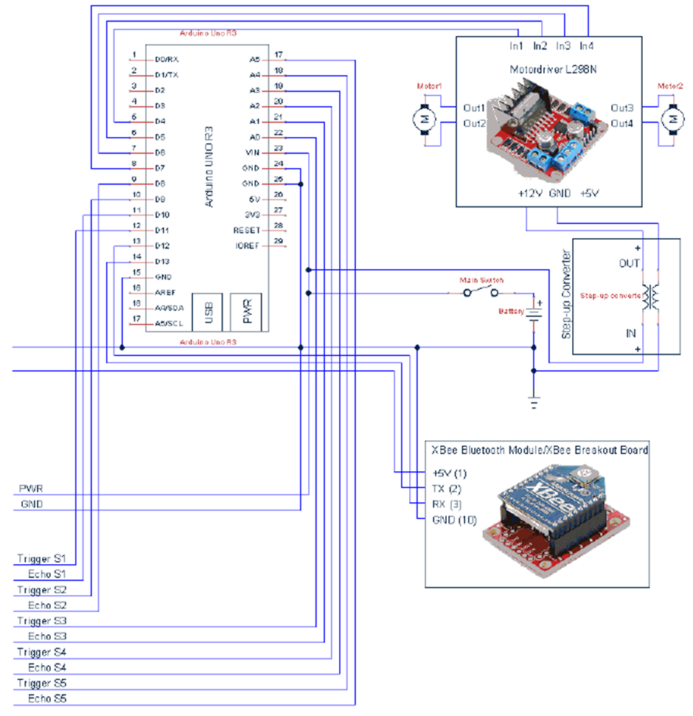

Figure 9-1 – Wiring in general electronics (Part 1)

----------------------------------------------------------------------------------------------------------------------95p

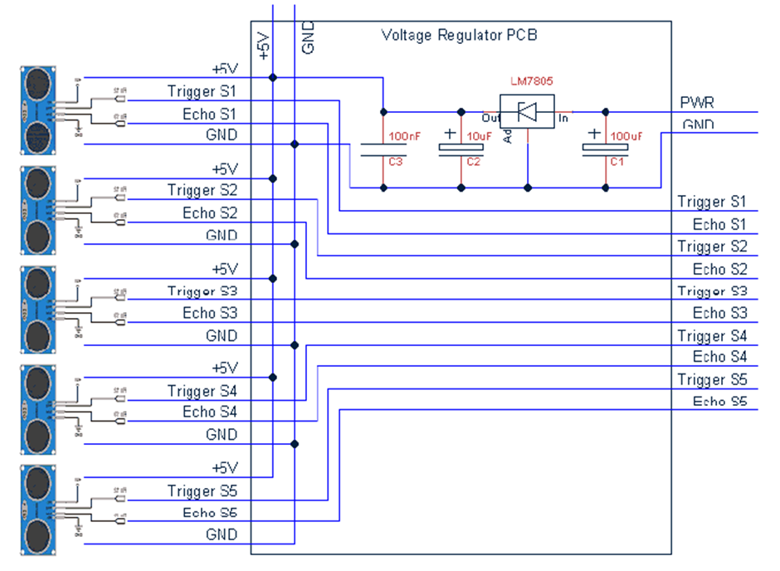

Figure 9.2 – Wiring for voltage regulator and sensors (Part 2)

----------------------------------------------------------------------------------------------------------------------96p

9.2 B) Flowchart of table method

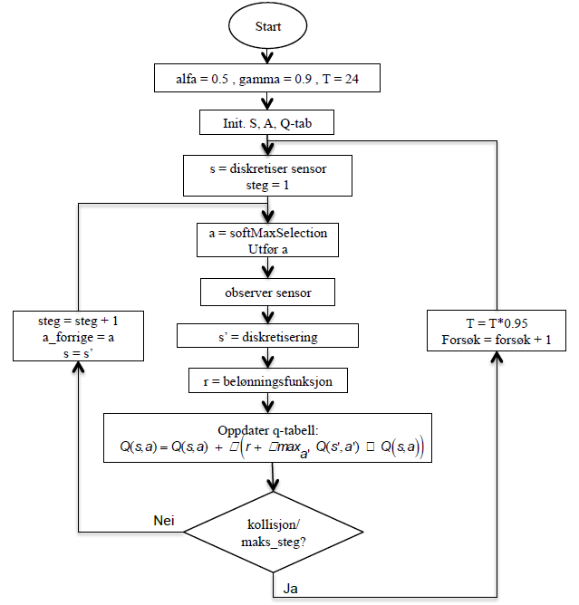

**collision /**

**max_steg?**

**Update Q-table :**

**r = reward function**

**s’ = discretization**

**Observable sensor**

**Yes**

**No**

**Attempts = attempts + 1**

**Step = step + 1**

**a = softMaxSelection**

**Perform a**

**S = discretization sensor**

**Step = 1**

Figure 9-3 – Flowchart Table method

----------------------------------------------------------------------------------------------------------------------97p

9.3 C) Flowchart for neural network

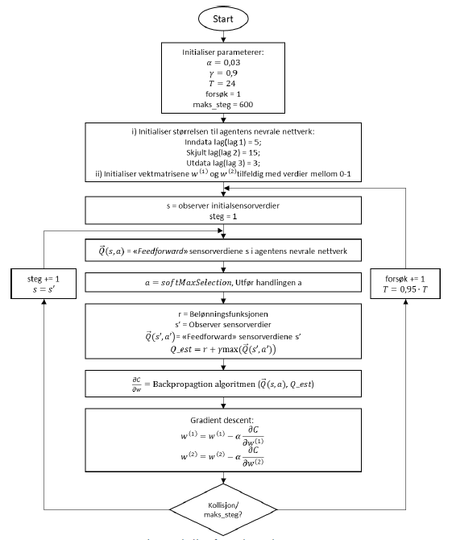

Figure 9-4 – Flowchart for neural network

----------------------------------------------------------------------------------------------------------------------98p

9.4 D) Flowchart for physical agent

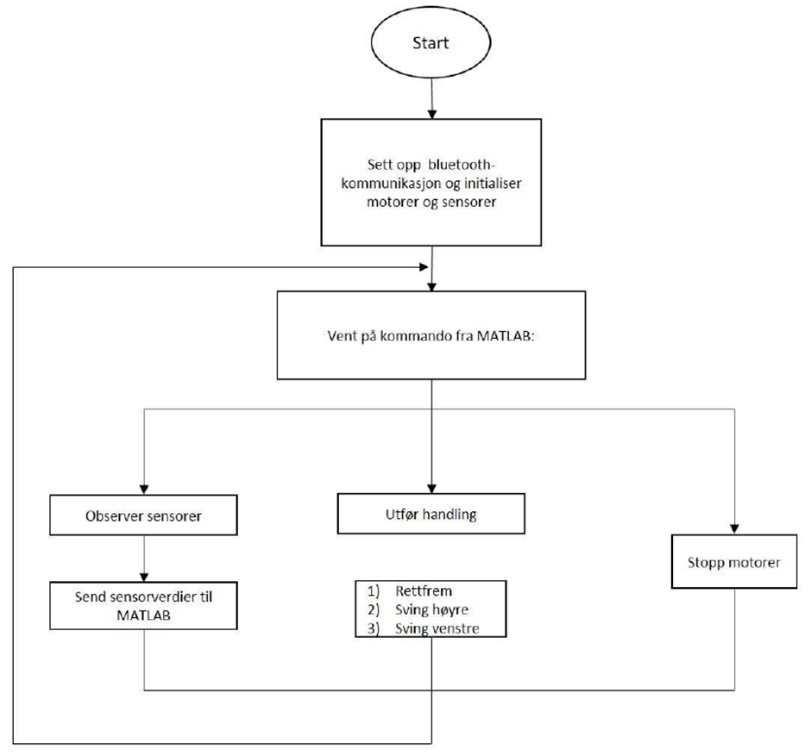

Figure 9-5 – Flowchart of physical agent

----------------------------------------------------------------------------------------------------------------------99p